Project Plan

Arc Transit: Transit Operations Coordination and Operational-State Reconciliation Platform

Document Revision #: 2
Date of Issue: August 20, 2026

Project Developer
Chuckz Española

Table of Contents
1. Project Overview 1
1.1 Purpose, Scope, and Objectives 1
1.2 Assumptions and Constraints 1
1.3 Project Deliverables 2
1.4 Schedule and Budget Summary 2
1.5 Evolution of the Plan 2
1.6 References 2
1.7 Definitions and Acronyms 3
2. Project Organization 4
2.1 External Interfaces 4
2.2 Internal Structure 4
2.3 Roles and Responsibilities 4
3. Managerial Process Plans 5
3.1 Startup Plan 5
3.1.1 Estimates 5
3.1.2 Staffing 5
3.1.3 Resource Acquisition 5
3.1.4 Project Staff Training 6
3.2 Work Plan 6
3.2.1 Work Breakdown Structure 6
3.2.2 Schedule Allocation 7
3.2.3 Resource Allocation 7
3.2.4 Budget Allocation 7
3.3 Project Tracking Plan 8
3.3.1 Requirements Management 8
3.3.2 Schedule Control 8
3.3.3 Budget Control 8
3.3.4 Quality Control 9
3.3.5 Reporting 9
3.3.6 Project Metrics 9
3.4 Risk Management Plan 9
3.5 Project Closeout Plan 10
4. Technical Process Plans 11
4.1 Process Model 11
4.2 Methods, Tools, and Techniques 11
4.3 Infrastructure 11
4.4 Product Acceptance 12
5. Supporting Process Plans 13
5.1 Configuration Management 13
5.2 Verification and Validation 13
5.3 Documentation 14
5.4 Quality Assurance 14
5.5 Reviews and Audits 14
5.6 Problem Resolution 15
5.7 Subcontractor Management 15
5.8 Process Improvement 15
6. Additional Plans 16
Annex A 18
Annex B 19

Document Change Control
This section controls revisions to the Project Plan and records the evidence-driven change in scope.
Revision Number | Date of Issue | Author(s) | Brief Description of Change
2 | August 20, 2026 | Chuckz Española | Revised the project from a student portfolio prototype into a research- and feasibility-driven transit operations plan centered on operational-state integrity, provenance, freshness, reconciliation, exception handling, route/fleet state modeling, and explicit feasibility and trade-off analysis based on Philippine transport conditions and existing production systems.

Project Overview
Arc Transit is a browser-based transit operations coordination and operational-state reconciliation platform for bus operators that must work with incomplete, delayed, manually reported, or otherwise heterogeneous operational information. It maintains a central record of fleet capacity, service assignments, routes, drivers, incidents, maintenance, field observations, verification status, state history, operational exceptions, and audit history. The project is a proposed engineering solution that will be evaluated for technical, operational, data-quality, security, and feasibility trade-offs.
Philippine evidence shows that franchised/authorized fleet does not necessarily equal actual service supply; the September 2025 Commonwealth Avenue case involved 3,972 franchised PUVs whose actual operation had to be verified, and the transport secretary stated that dispatching cannot solve the supply problem when vehicles are not operational [S1]. Philippine service-contracting operations have used both GPS tracking and manual monitoring, while the April 2026 change removing the GPS installation requirement for participating PUVs and using QR-based kilometer monitoring demonstrates that lower-infrastructure monitoring is operationally relevant but does not make manual records equivalent to telemetry [S2][S3]. Route structures can change during ongoing operations, LTFRB announced the rationalization of 12 PUV routes in January 2026, while LTO treats roadworthiness inspection as a distinct operational control with electronically recorded inspection results [S4][S5].
Mature systems already provide telemetry, planning, dispatch, incident/disruption management, maintenance, and passenger-information capabilities.
INIT documents field-to-central-data divergence, while Optibus, HASTUS, CleverCAD, Samsara, Geotab, and Seoul TOPIS represent progressively more integrated or telemetry-rich operating models [S6][S7][S8][S9][S10][S11][S12].
Furthermore, Arc Transit therefore does not claim novelty in generic fleet management, dispatch, scheduling, telemetry, or incident handling. The proposed contribution is rather a smaller operational coordination layer that explicitly models planned state, assigned state, field-reported state, verification state, freshness, contradictions, state transitions, and recovery history when continuous vehicle telemetry is unavailable or intentionally not assumed.

Purpose
The project aims to develop and evaluate a transit operations coordination platform that addresses operational-state integrity under low-instrumentation or mixed-verification conditions. It focuses on improving how bus operators record, coordinate, reconcile, and monitor operational information when data may be manually reported, delayed, incomplete, contradictory, or not independently verified.
The system will:
- Centralize operational information covering planned service, vehicle and driver assignments, field observations, incidents, maintenance, route changes, and auditable state transitions.
- Improve operational coordination by providing visibility into current assignments, usable service capacity, unresolved disruptions, stale reports, contradictory states, and other operational exceptions that require attention.
- Preserve the source, timing, verification state, and history of operational information so that changes can be traced from the original report or event through subsequent actions and resolution.
- Support the evaluation of the proposed approach through measurable experiments involving data completeness, update latency, stale-state detection, contradiction detection, recovery traceability, audit completeness, and software performance.
- Assess the technical and operational feasibility of the proposed solution, including its limitations, implementation constraints, risks, and trade-offs, without claiming unvalidated city-scale improvements in congestion, passenger travel time, safety, or regulatory compliance.

Scope
This project covers the research, design, development, implementation, and evaluation of a browser-based transit operations coordination and operational-state reconciliation platform for bus operations under low-instrumentation or mixed-verification conditions. The system is intended to maintain a central and auditable operational record while supporting coordination between planned service, fleet resources, assignments, field observations, incidents, maintenance activities, and operational exceptions.
Key features include:
- A browser-based operations platform accessed through secure HTTPS for authorized operational and administrative users.
- A central operational record covering planned service, vehicle and driver assignments, manual field observations, incidents, maintenance, verification state, freshness state, and auditable operational-state transitions.
- Fleet capacity and availability management that distinguishes authorized or administrative fleet records from current dispatchability and reported operating condition.
- Driver management, fixed-route and route-version management, dated service assignments, conflict checking, disruption handling, incident management, maintenance state, and operational exception workflows.
- Operational dashboards that emphasize exceptions and information quality, including stale reports, contradictory states, unresolved incidents, affected assignments, unavailable units, route or service disruptions, and current usable service capacity.
- Role-Based Access Control (RBAC), audit logging, source and provenance metadata, verification status, and controlled operational-state transitions.
- PostgreSQL persistence with Flyway migrations, append-only operational observation and state-history records, and transactional workflow integrity.
- Dockerized local and cloud-VM deployment to support reproducible testing and demonstration.
- Technical documentation covering the research basis, identified operational constraints, market and system comparison, gap analysis, operational model, architecture, database schema, feasibility assessment, experiments, measured results, limitations, trade-offs, and decision rationale.
The project is primarily focused on the development and evaluation of the web-based operational coordination platform and its supporting backend, database, workflows, and data-processing mechanisms. A separate native mobile application is not required for the baseline; however, a responsive browser-based workflow may be evaluated for authorized field reporting without introducing a second client stack. Automatic GPS/AVL or vehicle telemetry, automatic vehicle location, telemetry-derived ETA, and sensor-derived driving-behaviour scoring are outside the baseline. Fare collection, payment processing, reimbursement or payment settlement, and passenger fare administration are also excluded. A passenger-facing application or public passenger-information service is not included in the baseline, although integration may be considered as a future option. Production deployment with a transit authority or integration with live regulatory or dispatch networks is outside the current project because such deployment would require a real operator, operational data, governance arrangements, and a separate validation study.
Enterprise-scale distributed architecture, microservices, message brokers, and complex multi-site orchestration are likewise outside the baseline unless later research establishes a justified need. The project is not intended to replace commercial telematics, CAD/AVL, transit scheduling, or fleet-management platforms. It also does not claim automatic roadworthiness determination, engine diagnostics, predictive maintenance, mathematical scheduling optimization, quantified procurement-cost or affordability advantages, or city-scale improvements in congestion, passenger travel time, safety, or regulatory compliance.

Objectives
The objectives of this project are as follows:
- Investigate recently documented Philippine bus-transportation constraints and existing production transit, fleet-management, and intelligent transportation systems.
- Identify the operational and information-management gaps, capabilities, assumptions, and operational approaches relevant to the proposed project.
- Design and develop a functional transit operations coordination and operational-state reconciliation system based on the identified constraints, gaps, and feasibility considerations.
- Implement an auditable operational-state model that preserves operational history, source and provenance information, verification state, freshness state, and changes between planned, assigned, reported, and current conditions.
- Evaluate the system using measurable criteria including data completeness, update latency, stale-state detection, contradiction detection, recovery traceability, audit completeness, and software performance.
- Assess and document the technical and operational feasibility of the proposed solution, including implementation constraints, limitations, risks, and trade-offs.

Project Deliverables
To meet the system objectives, these deliverables will be supplied:
Functional Software System
- Transit Operations Coordination Platform. A working web browser-based system with a centralized dashboard for monitoring current operational conditions for managing fleet capacity and availability, drivers, routes and route versions, dated service assignments, dispatch workflows, incidents, maintenance states, operational observations, verification states, and operational exceptions.
- Operational-State and Reconciliation Functions. A functioning system-controlled state transitions, timestamped operational history, source and provenance metadata, verification and freshness indicators, contradiction or stale-state detection, and traceable operational responses.
- Security and Audit Controls. Working security features such as Role-Based Access Control, authenticated operational access, audit logging, and traceable state-changing actions.
Research and Technical Documentation
- Project Plan Documentation. Documentation of Philippine transport constraints, existing production and related systems, market or capability analysis, identified gaps, proposed software engineering enhancements, feasibility assessment, limitations, risks, and trade-offs.
- Technical Documentation. System architecture, operational model, database schema, module responsibilities, workflow definitions, state-transition rules, design decisions, and implementation rationale.
Testing and Evaluation Materials
- Reports. Results from functional, integration, workflow, and system testing.
- Experimental Evaluation. Measured results for data completeness, update latency, stale-state detection, contradiction detection, recovery traceability, audit completeness, and software performance.
- Feasibility and Limitation Assessment. Documentation of observed constraints, failed or unsupported assumptions, trade-offs, and conditions under which the proposed solution may or may not be practical.
Deployment Package
- Deployment Package. GitHub Source code, Docker configuration, database migration files, application configuration, and deployment instructions required to reproduce the system in a local or cloud-VM environment for testing and demonstration.

Methods
The following methods will be used to achieve the project objectives:
Research and Requirements Analysis
- Review documented Philippine bus-transportation constraints and operational conditions to identify requirements relevant to fleet availability, dispatching, route changes, operational reporting, incidents, maintenance, and information verification.
- Examine existing production transit, fleet-management, and intelligent transportation systems to identify established capabilities, operating assumptions, technical approaches, and limitations relevant to the proposed system.
- Translate the identified constraints and research findings into traceable system requirements and design decisions.
Gap and Feasibility Analysis
- Compare the identified Philippine operating constraints with the capabilities and assumptions of existing systems to determine relevant gaps and limitations.
- Evaluate proposed system enhancements according to technical feasibility, operational feasibility, infrastructure requirements, data-quality requirements, security implications, implementation complexity, and resource constraints.
- Document trade-offs, unsupported assumptions, alternative approaches, and conditions under which a proposed solution may not be practical.
Requirements and Design Traceability
- Maintain a Requirements Traceability Matrix (RTM) linking research findings, identified constraints, system requirements, proposed features, experiments, and project deliverables.
- Ensure that each major system feature can be traced to an identified operational problem, research finding, or evaluated gap rather than being introduced only as an arbitrary functionality.
System Development and Integration
- Develop the web browser-based transit operations platform using the approved modular architecture, database design, security controls, and operational workflows.
- Implement controlled operational-state transitions, append-only operational observations, source and provenance metadata, verification and freshness states, audit logging, conflict checking, incident handling, maintenance workflows, and operational exception detection.
- Integrate the system modules through defined application-service interfaces and transactional workflows while maintaining data integrity across fleet, driver, route, dispatch, incident, maintenance, and audit records.
Testing and Quality Assurance
- Conduct unit testing, integration testing, system testing, and workflow testing to verify that system components and operational processes behave according to their defined requirements.
- Test operational-state transitions, assignment conflicts, stale information, contradictory records, invalid inputs, authorization failures, audit events, and recovery workflows.
- Use controlled test scenarios to determine whether the system can preserve and reconstruct the sequence of events surrounding operational changes.
Experimental Evaluation and Performance Metrics
- Measure data completeness, update latency, stale-state detection, contradiction detection, recovery traceability, audit completeness, and software performance using controlled datasets and reproducible test scenarios.
- Compare expected system behavior against predefined evaluation criteria rather than assuming that implementation alone demonstrates operational effectiveness.
- Record actual measured results separately from planned targets and identify conditions that may have influenced the results.
Feasibility, Limitation, and Trade-off Evaluation
- Evaluate the system's effectiveness within low-instrumentation or mixed-verification conditions while explicitly recognizing that manually reported information cannot be independently proven accurate by the application alone.
- Assess the trade-offs between lower infrastructure requirements, manual reporting effort, information freshness, verification confidence, operational complexity, and system reliability.
- Document technical limitations, operational limitations, unsupported capabilities, failed assumptions, and potential improvements without claiming guaranteed city-scale benefits.
Feedback and Review
- Review the implemented workflows and evaluation results against the original research findings and identified operational constraints.
- Use observations from testing, controlled scenarios, and available stakeholder or user feedback to identify weaknesses, usability problems, and areas requiring further investigation.
- Incorporate justified findings into the final system design, documentation, feasibility assessment, and proposed future enhancements.

Integration Approach
This project will integrate the proposed transit-operations platform through its internal application modules, shared operational records, controlled application-service interfaces, and transactional workflows. The system will coordinate fleet, driver, route, dispatch, incident, maintenance, verification, and audit information through a common operational record. External integration with live transit-authority, regulatory, GPS/AVL, telematics, or commercial fleet-management systems is not required for the baseline implementation.
Future integration may be evaluated only where research demonstrates a clear operational benefit, technical feasibility, appropriate data access, and sufficient governance. The integration approach will therefore prioritize modularity, traceability, controlled data exchange, and the ability to preserve operational history when information from different sources differs or becomes unavailable.

Assumptions
- Availability of Documented Operational Information. The project assumes that sufficient documented Philippine transport constraints, existing-system information, and operational concepts are available to derive a defensible set of system requirements. Where evidence is incomplete, the limitation will be documented rather than replaced with an unsupported assumption.
- Mixed-Verification Operational Data. The project assumes that some operational information may be manually reported, delayed, incomplete, contradictory, or not independently verified. The system is therefore designed to record source, timing, verification state, freshness, and operational history rather than treating every submitted value as independently verified truth.
- Authorized Operational Users. The baseline assumes that designated administrative and operational users are available to enter, review, update, and reconcile operational information. The system does not assume that every operational participant requires a separate authenticated account.
- Sufficient Operational Resources. The proposed workflow assumes that an operator or organization has sufficient personnel, computing devices, and basic network access to use the browser-based system. The project does not assume the availability of vehicle-mounted GPS/AVL hardware, continuous telemetry, or dedicated mobile infrastructure.
- Controlled Operational Procedures. The system assumes that participating users will follow defined procedures for dispatching, reporting, incident recording, maintenance updates, and operational-state changes. However, user compliance is not assumed to be perfect; the system will therefore provide validation, auditability, stale-state identification, and exception handling.
- Data Security and Access Control. The project assumes that operational records should only be accessible to authorized users and that role-based permissions, authenticated access, secure communication, and audit logging can be implemented for the baseline environment.
- Reproducible Testing Environment. The project assumes that a controlled development, test, and demonstration environment can be established using PostgreSQL, Docker, the selected application stack, and simulated or manually generated operational data. Successful deployment in this environment does not imply production readiness.

Constraints
Schedule
- Limited Project Timeline. The design, implementation, testing, experimentation, documentation, and final evaluation must be completed within the available project period.
- Research Dependency. Requirements and system features depend on the results of transport-constraint research, market analysis, existing-system comparison, and feasibility assessment. Major findings that invalidate an assumed solution may require redesign rather than simple feature additions.
- Validation Time. Controlled experiments require preparation of datasets, scenarios, test cases, measurements, and repeated runs. The available time may limit the depth of experimental validation.
- Scope Control. The project must avoid expanding into GPS/AVL, enterprise scheduling optimization, passenger information systems, fare processing, or other large subsystems unless later evidence establishes a justified requirement.
Budget
- Limited Infrastructure Budget. The project may not support continuous investment in vehicle-mounted GPS, AVL equipment, telemetry devices, specialized hardware, or enterprise transportation infrastructure.
- Operational Costs. Hosting, storage, network services, monitoring, backups, domain services, and other operational resources may introduce recurring costs.
- External System Costs. Commercial transit, fleet-management, telematics, CAD/AVL, scheduling, or optimization platforms may involve procurement, licensing, integration, or data-access costs that cannot be assumed within the project.
- No Unsupported Affordability Claim. Public product information reviewed for the research is insufficient to establish a quantified procurement-cost advantage. The project therefore cannot treat lower cost as a proven outcome without an actual cost study or vendor quotations.
Resources
- Human Resources. A real operating organization may have limited personnel available for dispatching, data entry, verification, incident reporting, and maintenance updates.
- Technical Resources. Operators may have limited access to devices, reliable network connectivity, storage, or technical support.
- Operational Expertise. The project does not assume that all users have the same technical knowledge or that current operational procedures are already standardized.
- External Data Access. Access to live regulatory, operator, telematics, or transit-authority systems cannot be assumed without an actual partner, permission, data agreement, and compatible interface.
Quality
- Operational Data Quality. Manually reported information may contain missing values, incorrect values, delayed submissions, contradictory observations, or outdated states. The system can identify and record these conditions but cannot independently prove the physical truth of every manual report.
- Information Freshness. Dashboard usefulness depends partly on how recently operational observations were submitted. A current database record does not automatically mean that the underlying operational condition is still current.
- Verification Limitations. Audit logging provides evidence of recorded actions and their timing, but does not independently verify that a reported operational condition was physically true.
- System Reliability. The application must maintain transactional integrity and preserve operational history, but controlled prototype testing cannot establish reliability under city-scale production traffic or real-world operational conditions.
- Testing Limitations. The absence of a live operator, production operational data, and long-term deployment environment limits the ability to validate real-world transit outcomes.
Software to be Reused
- The project will use established frameworks, libraries, database technology, security components, testing tools, and supporting software where appropriate. Reusing mature software reduces unnecessary implementation effort, but dependency compatibility, maintenance status, and security vulnerabilities must still be evaluated.
Existing Software to be Incorporated
- Existing commercial and public transit systems such as fleet telematics, CAD/AVL, scheduling, optimization, or passenger-information platforms are treated as reference systems in the research rather than as components of the baseline implementation.
- Direct integration with such systems requires compatible interfaces, authorization, data agreements, technical documentation, and an operational partner. These conditions are not assumed to exist for the current project.
Technology to be Used
- The baseline implementation will use the approved application architecture, relational database, security framework, migration tooling, containerization, and testing infrastructure defined in the technical design.
- Technology selection may be revised when current official documentation, dependency compatibility, security considerations, or feasibility findings demonstrate that an existing choice is outdated or unsuitable.
External Interfaces
- The baseline does not depend on live external APIs for core operation.
- Future interfaces may include telematics, GPS/AVL, regulatory systems, passenger-information services, or other operational data sources, but these integrations require separate feasibility, security, data-ownership, availability, and governance evaluation.

Risks
Schedule
- Unforeseen Research or Technical Delays. New evidence, conflicting sources, implementation problems, dependency changes, or unexpected technical defects may require redesign or additional validation work.
- Scope Creep. Additional requests for GPS tracking, mobile applications, predictive maintenance, optimization, passenger information, or other enterprise functions may significantly expand the project beyond its validated problem scope.
- Validation Delays. Preparing controlled scenarios and obtaining sufficiently representative datasets may delay the measurement and evaluation phase.
Budget
- Cost Overruns. Additional infrastructure, hosting, testing, storage, external services, or specialized hardware may introduce costs beyond the initial project resources.
- Infrastructure Expansion. If later feasibility testing demonstrates that hardware, telemetry, stronger hosting, or external systems are required, the required investment may exceed the baseline project's resources.
- Unsupported Cost Expectations. Assuming that a lightweight architecture is automatically cheaper than commercial systems may produce an invalid conclusion without actual procurement and operating-cost data.
Resources
- Insufficient Operational Participation. Limited availability of dispatchers, operators, or other domain personnel may reduce the quality of workflow validation and operational feedback.
- Overburdened Users. Users responsible for dispatching or field reporting may have insufficient time to continuously update the system, increasing the risk of stale or incomplete operational information.
- Limited Technical Support. Lack of personnel experienced in deployment, database administration, networking, or system maintenance may affect long-term operation.
- Limited External Access. Lack of an actual operator or authority partner may prevent validation against live operational data.
Quality
- Data Inconsistency. Different users may report different conditions for the same vehicle, assignment, or route. Failure to identify and preserve these contradictions could produce misleading operational summaries.
- Stale Operational State. A previously valid report may become outdated while remaining present in the central record. Failure to identify stale information may cause users to make decisions using obsolete conditions.
- False Confidence. A well-organized audit trail may create the appearance of certainty even though manually entered observations are not independently verified.
- Incomplete Reconciliation. The system may fail to correctly reconcile planned, assigned, reported, and current operational states, resulting in inconsistent dashboards or incorrect exception indicators.
- Reduced System Performance. Performance may degrade as the number of operational records, concurrent users, historical observations, and audit records increases beyond the controlled benchmark environment.
- Security Issues. Weak authentication, authorization, configuration, dependency management, or data protection could expose operational information or allow unauthorized modifications.
Software to be Reused
- Dependency Vulnerabilities. Reused libraries and frameworks may contain security vulnerabilities, incompatible versions, deprecated components, or unexpected behavior.
- Dependency Changes. Updates to third-party frameworks or libraries may require code changes, regression testing, or architecture adjustments.
Existing Software to be Incorporated
- Integration Complexity. Connecting Arc Transit to external transit or fleet systems may require incompatible data models, undocumented interfaces, authentication mechanisms, or proprietary protocols.
- Data Synchronization Problems. External systems may provide information at different times or with different definitions of operational state, creating additional reconciliation requirements.
- External System Dependency. Failure or unavailability of an integrated third-party system could affect functions that depend on its data.
Technology to be Used
- Technology Obsolescence. Frameworks, runtimes, libraries, or infrastructure components may change during the project and could require updates or replacement.
- Knowledge Gaps. Limited experience with a selected technology may increase implementation time, defects, debugging effort, or dependency on external documentation.
- Architecture Overengineering. Introducing technologies such as microservices, message brokers, Kubernetes, or complex distributed infrastructure without a demonstrated requirement may increase operational complexity without improving the identified problem.
External Interfaces
- Third-Party API Downtime. Future integrations may depend on external services that can become unavailable or experience degraded performance.
- API and Data-Format Changes. External providers may change endpoints, authentication requirements, schemas, or data formats, requiring additional development and testing.
- Network Dependency. Live data exchange may fail when connectivity is unavailable or unreliable, potentially causing incomplete or delayed operational information.
- Data Ownership and Governance. External data may require authorization, agreements, privacy controls, or operational governance that cannot be established solely through software development.

Trade-off Analysis
The implementation scope is to investigate whether stronger state modeling, provenance, freshness, reconciliation, and exception handling can improve coordination when operational data is manually reported or only partially verifiable. Every proposed improvement has an explicit limitation: the system can improve the record and the decision workflow, but it cannot create telemetry, determine physical truth, solve vehicle shortages, or prove passenger-level outcomes without real deployment and an appropriate study design.

List of the following Excluded Features
Excluded feature | Why it is not included | Method of Approach
GPS / AVL / live telemetry | Continuous telemetry can provide location and sensor-derived state, but it requires vehicle hardware, connectivity, ingestion, validation, and ongoing operations. Philippine programs have demonstrated mixed GPS/manual monitoring and later relaxed GPS installation requirements for participation [S2][S3]. | Keep the baseline manual-first and design source/provenance fields so telemetry can later become another input source without changing the core business model.
Operational-state reconciliation | Explicit reconciliation adds state rules, freshness logic, contradiction checks, and UI complexity. It can reveal unresolved conditions rather than hiding them. | Implement as a bounded reconciliation layer and measure detection/recovery performance instead of claiming that reconciliation makes data truthful.
Verification metadata | Source/verification labels improve transparency but require human actions and may slow workflows. | Use lightweight verification states and require stronger verification only for actions or records defined as operationally significant.
Route versioning | Effective-dated route versions preserve history but increase model complexity. Philippine route rationalization demonstrates that route structures can change while operations continue [S4]. | Use versioned route definitions for changes that affect service meaning; retain simple status fields for non-breaking administrative changes.
Stale/contradictory state detection | Rules can identify suspicious records but cannot establish whether the underlying field report is physically correct. Excessive alerts can create alert fatigue. | Use configurable freshness thresholds, severity, deduplication, and exception queues rather than continuous modal warnings.
Manual field reporting | Manual entry avoids vehicle hardware but introduces human error, delay, incomplete information, and verification uncertainty [S2][S3]. | Minimize required fields, capture observation time separately from recording time, use structured states, and preserve correction history.
QR-assisted field reporting | QR-assisted browser access may reduce manual identification steps and aligns with a current Philippine PUV monitoring mechanism, but this does not prove that an Arc workflow will be effective [S3]. | Treat QR reporting as a controlled experiment or later phase; evaluate authorization, connectivity, device availability, abuse resistance, and workflow speed before making it mandatory.
Offline-first operation | Offline storage can help in poor connectivity but introduces synchronization, duplicate-event, timestamp, authentication, and conflict-resolution complexity. | Do not make offline-first a baseline requirement. Prototype only if field research shows connectivity is a material constraint for the intended context.
Advanced scheduling optimization | Enterprise products already provide deep timetable, vehicle-block, crew, and resource optimization [S9][S10]. | Do not reproduce mathematical optimization. Concentrate on assignment integrity, operational state, disruptions, traceability, and exception support.
Commercial system replacement | Commercial fleet/transit platforms already provide broader telemetry, planning, dispatch, incident, maintenance, and passenger-information functions [S6][S7][S8][S9][S10][S11][S12]. | Position Arc as a bounded coordination/reconciliation layer or research prototype that can coexist with existing systems rather than replace them.
Affordability claim | The reviewed public vendor material does not establish comparable Philippine procurement or operating costs. | Do not claim the proposal is cheaper without actual quotations, implementation assumptions, and a total-cost study.
Real-world impact claims | A controlled prototype test cannot establish reduced congestion, reduced passenger travel time, improved safety, or regulatory compliance at city scale. | Limit validation to measurable information/workflow outcomes and state the boundary of inference explicitly.

Project Schedule
Arc Transit will be developed as a personal software engineering and research project over a twelve-week development period. The schedule is organized around research, system design, implementation, testing, experimental evaluation, and final documentation. The sequence is intended to provide a practical development path while allowing requirements or design decisions to be revised when research findings, feasibility results, technical issues, or testing results indicate that a change is necessary.
Research, Requirements, and Architecture (Weeks 1-4)
- Review documented Philippine bus-transportation constraints and relevant operational problems.
- Examine existing production transit, fleet-management, and intelligent transportation systems.
- Identify system assumptions, gaps, feasibility constraints, and proposed operational-state requirements.
- Establish the project scope, objectives, Requirements Traceability Matrix (RTM), operational model, and initial feasibility criteria.
- Complete the system architecture, database design, module boundaries, security approach, and major workflow definitions.
Application Foundation and Core Development (Weeks 5-8)
- Implement the application foundation, PostgreSQL database, Flyway migrations, authentication, authorization, audit support, and initial Fleet workflow.
- Implement the core Fleet, Driver, Route, and Dispatch workflows.
- Implement controlled operational-state transitions, assignment conflict checking, and transactional workflow rules.
- Update technical documentation when implementation decisions or system behavior differ from the original design.
Operations Dashboard and Reconciliation Features (Weeks 9-10)
- Implement incident, maintenance, manual operational-status, verification, freshness, and exception-handling workflows.
- Implement the operational dashboard for fleet condition, usable service capacity, assignments, incidents, disruptions, stale information, and contradictory states.
- Validate the interaction between operational modules and the central operational-state model.
Testing, Experimental Evaluation, and Documentation (Weeks 11-12)
- Execute unit, integration, system, and workflow tests.
- Conduct controlled experiments for data completeness, update latency, stale-state detection, contradiction detection, recovery traceability, audit completeness, and software performance.
- Record actual measured results and compare them with the predefined evaluation criteria.
- Correct defects and unresolved issues identified during testing.
- Complete the technical documentation, feasibility assessment, limitations, trade-off analysis, deployment materials, and final project report.

Budget Summary
Arc Transit is a personal project and does not currently require a dedicated project budget. Development will use available computing resources, open-source software, existing development tools, and simulated or manually generated operational data. The project does not assume expenditure for commercial transit software, GPS/AVL hardware, vehicle telemetry equipment, external consultants, paid development tools, or production infrastructure.
Any future expenditure required for external services, production deployment, specialized hardware, commercial software, or live-system integration will be treated as a separate feasibility consideration rather than as part of the baseline project budget.

Evolution of the Plan
Arc Transit is treated as a personal research and software-engineering project rather than a commissioned institutional system. The project plan will therefore remain iterative and controlled, with changes made when research findings, feasibility assessment, implementation results, testing, or newly identified technical constraints justify a revision.
The plan will be updated at major development checkpoints and whenever a significant change affects the project's scope, architecture, requirements, database design, operational model, evaluation method, or identified risks. Minor implementation changes that do not affect the approved project direction may be recorded through normal version-control history without requiring a full revision of the project plan.
The project will use Git and GitHub for source-code version control and change history. The technical documentation and project-plan revisions will be maintained alongside the implementation so that important design changes remain traceable to the corresponding software changes.
Changes will generally follow this sequence:
- Change Identification. A research finding, feasibility issue, technical limitation, testing result, or implementation requirement identifies a potential change.
- Impact Assessment. The change is evaluated against project scope, technical feasibility, schedule, resource requirements, system dependencies, testing requirements, and existing design decisions.
- Decision. The change is accepted, deferred to a future iteration, or rejected when it introduces unjustified complexity or moves the system outside the identified problem scope.
- Documentation and Implementation. Approved changes are reflected in the relevant requirements, architecture, database design, implementation, tests, and project documentation.
The project follows the Agile-Kanban approach defined for Arc Transit. The work is prioritized according to current requirements and evidence, implementation is reviewed as it progresses, and documentation is updated when the architecture, database, or system behavior changes.

Internal Structure
Arc Transit is a personal research and software-engineering project developed and managed by a single project developer. Because the project does not have a separate development team, project management, system analysis, development, documentation, system administration, testing, and evaluation responsibilities are performed by the same individual.
The project follows a unified development structure in which the Project Developer is responsible for the complete project lifecycle, from research and requirements analysis through implementation, testing, deployment, documentation, and final evaluation.
Supporting Processes
- Configuration Management. Managed by the Project Developer using Git and GitHub to maintain source-code history, configuration changes, documentation revisions, and project versions.
- Quality Assurance. Performed by the Project Developer through code review, testing, requirements checking, database validation, security checks, and documentation review.
- Verification and Validation. Performed by the Project Developer through traceability checks, controlled test scenarios, experimental evaluation, performance measurements, and comparison of implemented behaviour against defined requirements and evaluation criteria.
- Research and Feasibility Review. Performed throughout the project to ensure that system decisions remain connected to documented transport constraints, existing-system findings, identified gaps, feasibility conditions, and stated trade-offs.

Roles and Responsibilities
Role | Key Work Activity | Supporting Process
Project Developer | Overall project planning, research, requirements analysis, system design, software development, database engineering, deployment, testing, evaluation, and documentation. | Project management, configuration management, research review, quality assurance, verification and validation.
Research and System Analysis | Research Philippine transport constraints, evaluate existing systems, identify assumptions and gaps, define requirements, and maintain the RTM. | Requirements analysis, feasibility assessment, research traceability.
Software Development | Develop frontend and backend functions, operational workflows, state transitions, reconciliation logic, incident handling, maintenance workflows, and exception detection. | Code review, unit testing, integration testing.
Database and Data Engineering | Design PostgreSQL schema, Flyway migrations, constraints, indexes, audit records, operational history, and data-integrity rules. | Database validation, migration testing, transaction integrity checks.
System Architecture | Define module boundaries, application-service interfaces, security architecture, deployment structure, and technical design decisions. | Architecture review, dependency evaluation, design documentation.
System Administration | Manage Docker configuration, local and cloud-VM deployment, application configuration, database environment, backups, and deployment procedures. | Configuration management, deployment verification, security checks.
Testing and QA | Execute functional, integration, system, workflow, performance, and experimental tests; investigate defects and verify requirements. | Quality assurance, verification and validation.
Documentation and Evaluation | Maintain the project plan, technical documentation, RTM, research records, test reports, feasibility assessment, limitations, and trade-off analysis. | Documentation review, traceability, final evaluation.

Because Arc Transit is a single-developer project, these responsibilities are not separate organizational positions. They represent the different functions performed by the same Project Developer throughout the project lifecycle.

Work Plan
Work Breakdown Structure
The Arc Transit project work is organized into sequential but iterative work activities covering research, requirements analysis, system architecture, database and service design, application development, operational-state and reconciliation features, testing, experimental evaluation, deployment, and final documentation.
Because Arc Transit is a personal single-developer project, the Work Breakdown Structure represents the planned project process rather than a division of work among separate personnel. Individual tasks are managed through the Agile-Kanban Progress Tracker, while this Project Plan provides the higher-level structure and expected outputs for each major phase.
- Research and Requirements Analysis
  - Review documented Philippine bus-transportation constraints and operational issues relevant to fleet availability, dispatching, route changes, incidents, maintenance, and operational information.
  - Examine existing production transit, fleet-management, and intelligent transportation systems.
  - Identify capabilities already addressed by existing systems, their operating assumptions, and the gaps that remain relevant to the proposed operating context.
  - Define the project purpose, objectives, scope, exclusions, requirements, and feasibility criteria.
  - Maintain the Requirements Traceability Matrix (RTM) linking research findings, requirements, system features, verification methods, and project deliverables.
- System Architecture and Operational Model
  - Define the operational-state model and state transitions for vehicles, drivers, trips or assignments, incidents, and related operational records.
  - Define the coordination and reconciliation approach for planned, assigned, reported, verified, and current operational states.
  - Finalize user flows, security roles, module responsibilities, runtime architecture, and major technical decisions.
  - Evaluate architecture alternatives and document decisions according to project requirements and practical constraints.
- Database and Application-Service Design
  - Design the core operational ERD and security/audit data model.
  - Define tables, relationships, PostgreSQL types, constraints, indexes, audit fields, and data-integrity rules.
  - Define Flyway migration structure and database ownership boundaries.
  - Define application-service interfaces, commands, queries, view models, authorization boundaries, transaction boundaries, validation rules, error handling, and internal events.
- Application Foundation and Security
  - Initialize the application runtime, build configuration, module structure, PostgreSQL environment, Flyway configuration, and browser-based interface.
  - Implement authentication, role-based access control, protected navigation, and audit foundations.
  - Establish the development and testing environment using the selected Java, Spring, Vaadin, PostgreSQL, and Docker components.
  - Verify the application foundation before beginning dependent operational modules.
- Core Transit Operations
  - Implement Fleet management and operational availability.
  - Implement Driver records and validation.
  - Implement fixed Routes, Stops, route schedules, and route-version handling.
  - Implement Dispatch and Assignment workflows, including availability checks, assignment conflicts, lifecycle transitions, cancellation, and audit events.
- Operational-State Reconciliation and Exception Management
  - Implement manual operational observations and state-history records.
  - Implement source and provenance information, verification state, and freshness state.
  - Implement incident reporting, response, resolution, and maintenance workflows.
  - Detect operational contradictions, stale information, unavailable resources, unresolved incidents, affected assignments, and other defined exceptions.
  - Preserve the operational history required to reconstruct changes and responses.
- Operational Dashboard and Analytics
  - Implement dashboard summaries for fleet condition, usable service capacity, assignments, incidents, maintenance, disruptions, stale information, and contradictory states.
  - Implement filtering and operational search functions.
  - Present operational records and exception information using persisted application data.
  - Ensure dashboard results are derived from the defined operational-state model rather than unsupported assumptions about live vehicle location.
- Testing and Experimental Evaluation
  - Perform unit, integration, module, security, workflow, browser, and database tests.
  - Validate state transitions, assignment conflicts, authorization boundaries, audit events, stale-state detection, and contradiction detection.
  - Conduct controlled experiments for data completeness, update latency, recovery traceability, audit completeness, and other defined evaluation measures.
  - Measure planned software-performance targets using the documented benchmark datasets and test conditions.
  - Record actual results separately from planned targets.
- Deployment and Final Release
  - Verify Docker-based application startup and database initialization.
  - Prepare the reproducible deployment environment and deployment documentation.
  - Correct release-blocking defects and complete required regression testing.
  - Finalize README.md, screenshots, technical documentation, limitations, trade-offs, and release records.

Project Milestones
The project is planned across twelve weeks using Agile-Kanban. Two-week progress reviews are used to evaluate completed work, carry forward incomplete tasks, and adjust priorities when technical issues, learning requirements, or research findings require changes. The detailed task status is maintained in the separate Agile-Kanban Progress Tracker.
The planned milestones with the following expected accomplishment are:
- Week 2 - Requirements and Architecture. Scope, requirements, user flows, modules, security approach, operational model, and system architecture documented.
- Week 4 - Database and Service Design. ERDs, data types, constraints, indexes, database conventions, and application-service contracts completed.
- Week 6 - Application Foundation. Runnable application with PostgreSQL, Flyway, authentication, role checks, audit support, and the initial Fleet workflow.
- Week 8 - Core Operations. Fleet, Driver, Route, and Dispatch workflows operating through the Vaadin interface.
- Week 10 - Operations Dashboard and Reconciliation. Incident, Maintenance, operational-status, verification/freshness, exception, dashboard, and analytics functions integrated.
- Week 11 - Testing and Evaluation. Functional, integration, security, workflow, experimental, and performance testing completed with results recorded.
- Week 12 - Deployment and Final Release. Deployment verified, defects corrected, benchmarks documented, README and screenshots completed, and final project documentation released.

Work Dependencies
The major work dependencies are:
Research and Requirements
  - Architecture and Operational Model
  - Database and Service Design
  - Application Foundation
  - Core Transit Operations
  - Reconciliation and Exception Features
  - Dashboard and Analytics
  - Testing and Experimental Evaluation
  - Deployment and Final Release
Some activities may proceed iteratively when implementation findings require revisions to earlier decisions. The Agile-Kanban process allows incomplete or blocked tasks to remain visible and return to In Progress when corrective work is required.
Examples of important dependencies include:
- Database and service implementation depends on a sufficiently stable requirements and operational model.
- Dispatch implementation depends on Fleet, Driver, Route, and schedule availability rules.
- Reconciliation and exception workflows depend on the operational-state model and underlying operational records.
- Dashboard analytics depend on persisted and validated operational data.
- Experimental evaluation depends on implemented workflows, controlled datasets, and defined measurement procedures.
- Final release depends on completion of testing, defect correction, deployment verification, and documentation.

Risk Factors and Mitigation
Research and Requirements
Risk Factors:
- Incomplete or conflicting evidence.
- Discovery of constraints that invalidate an earlier design assumption.
- Expansion of requirements beyond the identified problem.
Mitigation:
- Record the evidence and limitation explicitly.
- Reassess affected requirements and architecture before implementation.
- Use the RTM and approved scope to control unnecessary expansion.
Architecture and Design
Risk Factors:
- Architecture changes after implementation has started.
- Technology incompatibility or outdated dependencies.
- Unnecessary infrastructure complexity.
Mitigation:
- Evaluate technical decisions before implementation.
- Verify current official documentation and dependency compatibility.
- Prefer the simplest architecture that satisfies the demonstrated requirement.
Application Development
Risk Factors:
- Implementation defects.
- Cross-module dependencies.
- Database or transaction conflicts.
- Development tasks taking longer than estimated.
Mitigation:
- Maintain small Kanban work items.
- Test modules and workflows before beginning dependent functionality.
- Record blocked work and the required next action.
- Carry unfinished tasks forward rather than masking incomplete work.
Operational Data Quality
Risk Factors:
- Missing or incorrect manual reports.
- Stale operational states.
- Contradictory reports.
- Lack of independent verification.
Mitigation:
- Preserve source, timestamp, verification, and freshness information.
- Detect stale and contradictory states where defined.
- Preserve event history instead of silently overwriting previous conditions.
- Explicitly label limitations instead of treating manual data as telemetry.
Testing and Evaluation
Risk Factors:
- Insufficient representative test scenarios.
- Performance targets being mistaken for actual results.
- Limited real-world operational validation.
Mitigation:
- Use controlled and reproducible scenarios.
- Report measured results separately from targets.
- Evaluate the software as a coordination workflow rather than claiming city-scale transportation outcomes.
Schedule
Risk Factors:
- Technical debugging taking longer than planned.
- Research-driven redesign.
- Tasks becoming blocked by dependencies.
Mitigation:
- Use two-week progress reviews.
- Keep one primary implementation task active when practical.
- Re-prioritize work based on dependencies and evidence.
- Maintain future ideas separately from the approved scope.

Project Tracking Plan
Requirements Management
- Requirements will be managed through the Requirements Traceability Matrix (RTM), project documentation, and the Agile-Kanban Progress Tracker.
- Each major requirement will be traceable to its research basis, identified transport constraint, proposed system response, verification method, and corresponding deliverable where applicable.
- Requirement changes may be introduced when new research findings, feasibility analysis, implementation constraints, testing results, or technical discoveries indicate that the existing requirement is incomplete, impractical, or no longer justified.
- Before implementing a significant requirement change, its effect on project scope, architecture, schedule, data model, testing requirements, and existing functionality will be assessed.
- Approved changes will be recorded in the relevant project documentation and source-control history. Requirements that are not justified for the current scope may be deferred to a future roadmap rather than added immediately.
- The Agile-Kanban tracker will be used to convert approved requirements into implementation tasks with defined expected results and dependencies.
- Requirements management will remain aligned with the project's research-driven approach so that features are not added solely because they are technically possible or visually desirable.
Schedule Control
- Project progress will be tracked using the Agile-Kanban Progress Tracker and GitHub repository history.
- The baseline schedule consists of twelve planned development weeks divided into research and requirements, architecture and design, database and service design, application development, operational workflows, testing and evaluation, deployment, and final documentation.
- Two-week progress reviews will be used to compare completed work against the planned milestones and determine whether tasks should remain in progress, move to testing and review, be marked completed, or be carried forward.
- The Kanban states used by the project are Planned, Ready, In Progress, Testing and Review, Completed, and Blocked.
- When delays occur, remaining work may be reprioritized according to dependencies, technical risk, research findings, and project value rather than forcing the original schedule to remain unchanged.
- Tasks that become blocked will remain visible in the tracker with the identified blocker and required next action.
- The detailed Agile-Kanban Progress Tracker will serve as the current working schedule, while this Project Plan provides the higher-level schedule and milestone structure.
Budget Control
- Arc Transit is a personal project with a baseline project budget of ₱0.
- The project will primarily use existing computing resources, open-source software, available development tools, and simulated or manually generated operational data.
- Commercial transit software, GPS/AVL hardware, specialized telemetry equipment, external consultants, and production infrastructure are not assumed to be part of the baseline project budget.
- Any unexpected expense associated with hosting, specialized tools, external services, or future infrastructure will be recorded separately and evaluated against the project's technical benefit and feasibility.
- No claim of commercial cost savings or affordability advantage will be made without an actual cost comparison using appropriate procurement and operating-cost information.
Quality Control
- Quality will be controlled through requirements traceability, code review, automated testing, manual validation, database validation, security checks, documentation review, and experimental evaluation.
- Each major implementation should be checked against its defined requirement and expected result before being considered complete.
- Unit, integration, module, workflow, security, browser, database, and performance testing will be used where applicable to the implemented feature.
- Operational workflows will be checked for correct state transitions, assignment conflicts, authorization rules, audit events, stale-state conditions, contradictory states, and data-integrity violations.
- Development quality will also be evaluated through the project's architecture and database rules, including module boundaries, transactional behavior, constraints, indexes, migrations, and error handling.
- Test results and benchmark measurements will be recorded as actual results. Planned targets will not be presented as completed measurements.
- A completed Kanban task will require its expected result to be produced and verified through the appropriate test, review, implementation evidence, or documentation update.
Reporting
- Project progress will be recorded through the Agile-Kanban Progress Tracker, Git commits, development notes, README updates, test records, and project-document revisions.
- Progress reporting will focus on completed work, current work, blocked work, remaining dependencies, research findings, design changes, defects, testing results, and decisions affecting project scope.
- Two-week progress reviews will be used as the primary formal project-review points.
- Immediate documentation updates may be made when a significant technical issue, research finding, scope change, or architecture decision affects the project.
- The final project documentation will summarize the implemented system, research basis, requirements traceability, measured results, feasibility findings, limitations, trade-offs, and lessons learned.
Project Metrics
- Project metrics will be collected from the Agile-Kanban tracker, GitHub history, testing records, benchmark results, and project documentation.
- Project execution metrics will include schedule progress, completed and blocked work, milestone completion, unresolved defects, and scope changes.
- Software quality metrics will include test results, defect counts, test failures, security findings, dependency issues, and successful verification of major requirements.
- Operational evaluation metrics will include data completeness, update latency, stale-state detection, contradiction detection, recovery traceability, and audit completeness.
- Performance metrics will include the predefined dashboard, search, login, and other benchmark measurements applicable to the implemented system.
- Metrics will be reviewed at milestone and testing stages to determine whether the project is progressing toward its stated objectives.
- Actual measurements will be distinguished from planned targets, estimates, or assumptions.

Risk Management Plan
This plan defines the process for identifying, assessing, monitoring, and mitigating risks that may affect the Arc Transit research, development, testing, and evaluation activities.
Risk Management Approach
- Initial Assessment. Risks will be identified during research, requirements analysis, architecture decisions, implementation planning, and technical design review
- Ongoing Management. Risks will be monitored throughout development and reassessed when new research findings, implementation problems, dependency changes, schedule delays, or testing results affect the project.
- Tracking and Evaluation. Significant risks will be recorded in the project documentation or development tracker together with their potential impact, mitigation approach, and current status.
- Decision-Based Mitigation. When a risk cannot be adequately reduced, the affected feature may be modified, deferred, reduced in scope.

Key Risk Factors and Mitigation Plans
Research and Requirements Risks
- New evidence may contradict an earlier assumption or reveal that a proposed feature is not relevant to the identified operating context.
- Reassess the requirement, document the evidence and limitation, and update the affected design before continuing implementation.
Scope Risks
- Additional ideas such as GPS/AVL, mobile applications, passenger services, predictive maintenance, or enterprise scheduling optimization may expand the project beyond the identified problem.
- Evaluate proposed additions against the research basis, feasibility, schedule, and boundaries. Defer unjustified additions to the future roadmap.
Technical Risks
- Framework incompatibility, dependency issues, architecture violations, database problems, or implementation defects may delay development.
- Verify technology compatibility, maintain version-controlled configuration, test dependent components early, and keep the architecture as simple as the demonstrated requirement allows.
Operational Data Risks
- Manually reported information may be incomplete, stale, contradictory, delayed, or inaccurate.
- Preserve source and timing information, record verification and freshness state, detect defined contradictions and stale records, and retain operational history instead of silently overwriting previous states.
Validation Risks
- The absence of a live transit operator, live operational data, or production deployment limits real-world validation.
- Use controlled datasets and reproducible test scenarios, clearly separate software-level measurements from real-world transport outcomes, and document validation limitations.
Security Risks
- Authentication, authorization, configuration, dependency, or data-protection weaknesses may compromise the system.
- Apply role-based access control, secure authentication, validation, controlled error handling, dependency checks, security testing, and audit logging.
Schedule Risks
- Debugging, redesign, testing, or research-driven changes may require more time than originally planned.
- Prioritize work through the Kanban tracker, keep blocked tasks visible, reprioritize dependent work, and prevent low-value features from displacing core requirements.

Responsibilities
Because Arc Transit is a single-developer project, all risk-management responsibilities are performed by the Project Developer. The Project Developer is responsible for identifying risks, evaluating their potential effect, selecting mitigation strategies, monitoring risk status, documenting decisions, and determining whether affected work should continue, change, be deferred, or be removed from the current project scope.

Project Closeout Plan
Project closeout will focus on completing the software implementation, preserving project evidence, documenting results, and establishing a clear final state for the Arc Transit project. Because the project is a personal software-engineering and research project, there is no separate staff reassignment, client handover, or formal institutional acceptance process.
Final Work Review
- Review the final implementation against the approved project scope and Requirements Traceability Matrix.
- Confirm that completed deliverables, tests, documentation, and deployment materials are present.
- Record incomplete or deferred functionality rather than representing unfinished work as completed.
- Review the final Kanban tracker and identify any work that remains blocked, deferred, or moved to the future roadmap.
Archiving Project Materials
- Source Repository. The final source code will be preserved in the project's GitHub repository together with its version history.
- Project Documentation. The final Project Plan, technical documentation, RTM, research materials, architecture artifacts, database documentation, test reports, and evaluation results will be retained in the project archive.
- Release Version. A final Git tag or release identifier may be used to distinguish the evaluated version from later development.
- Version History. Git history and documentation revisions will preserve significant implementation and design changes made during development.
Capturing Project Metrics
- Final Metrics Recording. Final results will be recorded for the project's defined software, quality, performance, and operational evaluation metrics.
- Requirements Verification. Completed requirements will be checked against the RTM to confirm whether they were implemented and how they were verified.
- Evaluation Summary. Actual measurements will be compared with the predefined evaluation criteria, with limitations and deviations documented.
Post-Project Review
- Self-Review. The Project Developer will review the project to identify successful decisions, failed assumptions, technical problems, research gaps, and areas for improvement.
- Lessons Learned. Important lessons regarding system architecture, database design, software development, research methodology, testing, and feasibility will be documented.
- Trade-off Review. Decisions that involved compromises between infrastructure requirements, complexity, data quality, verification, usability, maintainability, and scope will be reviewed and recorded.
Final Report Preparation
The final report will include:
- Project Overview. Final objectives, scope, operational problem, research basis, and system purpose.
- Research and Gap Analysis. Documented Philippine constraints, existing-system comparisons, identified gaps, and rationale for the proposed solution.
- System Implementation. Final architecture, database design, modules, workflows, security controls, and operational-state model.
- Performance and Evaluation Results. Actual testing, benchmark measurements, operational-state evaluation, and traceability results.
- Risk and Limitation Assessment. Risks encountered, mitigation actions, validation limitations, technical constraints, and unsupported claims.
- Lessons Learned. Key technical, methodological, and project-management lessons obtained during the development process.
- Future Recommendations. Potential enhancements, future integrations, further experiments, and conditions required for broader validation.
Final Release
- System Release. The final tested version of Arc Transit will be packaged with its required application configuration, database migrations, Docker configuration, and deployment instructions.
- Testing Completion. Required tests and final defect corrections will be completed before the release is marked final.
- Documentation Completion. README, technical documentation, architecture artifacts, screenshots, known limitations, and release notes will be finalized.
- Release Verification. The final release will be checked to ensure that the documented system behavior, source code, database structure, and deployment procedure remain consistent.
Future Maintenance and Sustainability
- Maintenance. Future maintenance will be performed as needed by the Project Developer if development of Arc Transit continues after the current release.
- Bug Tracking. Identified defects or improvement ideas will be recorded in the project's issue-tracking or repository workflow.
- Dependency Updates. Framework, runtime, library, and security updates will be evaluated before being incorporated into future versions.
- Future Development. Features that are not justified or feasible for may remain in the future roadmap for later research and development.
- No Production-Support Commitment. The project closeout does not establish a commitment to operate Arc Transit as a production transit-authority system. Any future production deployment would require a separate feasibility, governance, security, operational, and validation assessment.

Technical Process Plans
Process Model
Arc Transit follows an Agile-Kanban development process adapted for a personal, single-developer research and software-engineering project. The process combines planned project phases with iterative task management so that requirements, research findings, implementation results, and testing outcomes can be incorporated without losing control of project scope.
Relationships Among Activities
The major project activities are connected through a continuous flow:
Research and Requirements
- Architecture and Operational Model
- Database and Service Design
- Application Foundation
- Core Transit Operations
- Operational-State Reconciliation and Exception Handling
- Dashboard and Analytics
- Testing and Experimental Evaluation
- Deployment and Final Release
Supporting activities such as requirements traceability, risk management, quality assurance, configuration management, documentation, and verification and validation are performed throughout the project rather than being limited to one development phase.
Flow of Information and Work Products
Research findings are translated into requirements and recorded in the Requirements Traceability Matrix (RTM). Requirements are then reflected in the operational model, architecture, database design, application-service contracts, implementation tasks, and test cases.
Development outputs are reviewed through the Agile-Kanban workflow. Completed implementation work proceeds to testing and review, while defects, inconsistencies, or new technical findings may return the work to the In-Progress state.
Important project work products include:
- Research and constraint findings
- Project scope and objectives
- Requirements Traceability Matrix (RTM)
- Architecture and operational-state models
- ERDs, data dictionary, constraints, and indexes
- Application-service contracts
- Source code and database migrations
- Test cases and test results
- Benchmark and experimental evaluation results
- Deployment materials
- Final technical documentation and release records
Timing of Work Products
Major work products are aligned with the twelve-week project schedule. The first four weeks establish the documented design baseline, followed by application implementation, testing, evaluation, and final release activities.
The project tracker identifies the principal milestones as:
- Week 2 — Requirements and Architecture
- Week 4 — Database and Service Design
- Week 6 — Application Foundation
- Week 8 — Core Operations
- Week 10 — Operations Dashboard and Reconciliation
- Week 11 — Testing and Evaluation
- Week 12 — Deployment and Final Release
The Agile-Kanban Progress Tracker contains the detailed task-level schedule and is updated separately from this higher-level Project Plan.

Reviews to Be Conducted
Reviews are performed throughout the project to verify consistency between the research basis, requirements, design, implementation, and measured results.
Key reviews include:
- Requirements and scope review
- Architecture and operational-model review
- Database and service-contract review
- Implementation and code review
- Testing and verification review
- Experimental-results review
- Final release and documentation review
Two-week progress reviews are used to assess completed work, blockers, carried-forward tasks, and changes to project priorities.
Major Milestones
- Completion of Research, Requirements, and Architecture Baseline
- Completion of Database and Service Design
- Completion of Application Foundation
- Completion of Core Transit Operations
- Completion of Operational-State Reconciliation and Dashboard Functions
- Completion of Testing and Experimental Evaluation
- Final Deployment and Project Release
Baselines to Be Established
The project will establish baselines for:
- Project scope and boundaries
- Functional and non-functional requirements
- Operational-state model
- System architecture
- Database design
- Application-service contracts
- Performance evaluation criteria
- Testing and verification criteria
These baselines provide reference points for determining whether later changes represent justified improvements, necessary corrections, or scope expansion.

Project Deliverables
The principal deliverables are:
- Working Arc Transit software system
- PostgreSQL database schema and Flyway migrations
- Architecture and database documentation
- Requirements Traceability Matrix
- Test cases and test reports
- Experimental and benchmark results
- Feasibility, limitation, and trade-off assessment
- Dockerized deployment materials
- README, screenshots, and final project documentation
Required Approvals
Because Arc Transit is a personal project, formal client or institutional sign-off is not required. Instead, completion is determined through documented requirements, verification evidence, testing results, and self-review against the approved project scope and RTM.
A major work product is considered acceptable when its expected result has been produced and the appropriate implementation, test, review, or documentation evidence has been recorded.
Project Initiation and Termination
The project begins with research and requirements definition and proceeds through the twelve-week development plan. Project termination occurs when the final implementation, required testing, experimental evaluation, deployment materials, and project documentation have been completed and reviewed. Unfinished or unsupported features are not represented as completed deliverables. They are documented as limitations, deferred work, or future roadmap items.

Methods, Tools, and Techniques
Development Methodology
The project uses an Agile-Kanban methodology adapted for a single-developer workflow. Work is divided into manageable tasks with defined expected results and dependencies.
Tasks move through the following states:
State | Meaning | How it is used
Planned | Approved work retained for a later week or iteration. | Select when its timing and dependencies are appropriate.
Ready | Defined work with a clear task, expected result, and known dependencies. | May be started without further design clarification.
In Progress | Work currently being designed, implemented, or documented. | Keep active work limited so the current task can reach completion.
Testing and Review | Work being checked through tests, manual validation, or technical review. | Return it to In Progress when corrections are required.
Completed | The expected result has been produced and verified. | Record the completion date and the relevant result, commit, test, or document update.
Blocked | Work that cannot continue because of a technical issue, unresolved dependency, or required decision. | Record the blocker and the next action needed to resume work.

Two-week progress reviews are used to evaluate progress and reprioritize work when technical issues, research findings, or implementation constraints require changes. The project does not use Scrum-specific roles, daily stand-up requirements, or formal sprint ceremonies because the project is operated by a single developer.
Technologies and Programming Languages

The current application technology stack includes:
Technology | How the software is used
Java 21 | LTS baseline for the application, domain model, testing, and Vaadin UI. Vaadin 25 requires Java 21 or later [S14].
Spring Boot 4.1.0 | Current stable Spring Boot baseline verified against the official Spring documentation as of August 2026 [S13].
Spring Modulith 2.1.x | Module-boundary and application-module support inside a single deployable application. Stable 2.1.0 is documented in the current Spring Modulith release index [S15].
Vaadin Flow 25 | Server-side web UI baseline; current Vaadin guidance states Vaadin 25 uses Spring Boot 4 / Spring Framework 7 and requires Java 21+ [S14].
Spring Security | Session-based authentication and role checks for the browser application; security design remains server-side because the baseline has no separate public client.
PostgreSQL | Relational persistence for operational records, constraints, transactions, indexed queries, and append-only observation/state history.
Spring Data JPA / JDBC | JPA for transactional aggregates plus JDBC/explicit SQL for selected reconciliation, reporting, and aggregation queries where query visibility is important.
Flyway | Versioned SQL database migrations executed in a controlled order.
Maven | Build, test, dependency management, and packaging.
Docker Compose | Reproducible local deployment of the application and PostgreSQL services; cloud deployment remains a demonstration environment.

Processes, Tools, and Techniques
Specification
Requirements are derived from documented Philippine transport constraints, existing-system analysis, identified gaps, project objectives, and feasibility findings.
- Documentation Tools. Requirements Traceability Matrix, project documentation, research records, and Agile-Kanban tracker.
- Design. The project uses a modular monolith with defined application-service boundaries, controlled operational states, relational data integrity, role-based access control, and explicit workflow rules.
- System Documentation Tools. Architecture diagrams, ERDs, database documentation, user-flow documentation, and source-code structure.
- Development. Development is performed incrementally, with implementation divided into small work items and verified before dependent functionality is continued.
- Software Tools. Java, Spring Boot, Spring Modulith, Vaadin, PostgreSQL, Flyway, Maven, Git, GitHub, and Docker.
- Testing Tools. Testing combines unit testing, integration testing, module testing, security testing, workflow validation, browser testing, database testing, and performance benchmarking. Maven test framework, PostgreSQL Testcontainers, browser-based testing, application logs, and benchmark datasets.
- Documentation. Documentation is updated together with significant architecture, database, implementation, testing, and research changes. Microsoft Word, GitHub, README files, project tracker, RTM, and technical documentation.
- Evaluation. The software is evaluated through controlled scenarios rather than claims of real-world transit outcomes:
- Data completeness
- Update latency
- Stale-state detection
- Contradiction detection
- Recovery traceability
- Audit completeness
- Software performance
- Feasibility and limitation analysis

Technical Standards, Policies, and Procedures
- Requirements Traceability. Each major requirement should be traceable to its research basis, implementation target, verification method, and relevant project deliverable.
- Version Control. Git and GitHub will be used to maintain source-code history, significant implementation changes, and project versions
- Database Change Control. Database changes will be managed through Flyway migrations rather than uncontrolled schema changes.
- Testing Policy. Implemented functionality should be tested according to its risk and role within the system before being marked completed.
- Security Policy. Authentication, authorization, input validation, protected navigation, controlled error handling, and audit logging will be applied to the application.
- Documentation Policy. Significant changes to architecture, database design, workflow behavior, requirements, or evaluation criteria will be reflected in the corresponding documentation.
- Scope Control. Features that do not have a justified connection to the researched problem or approved scope will be deferred rather than automatically implemented.

Infrastructure
This section defines the development and deployment infrastructure required to build, test, and reproduce the Arc Transit system.
Development Environment
- Hardware. A personal development workstation capable of running the Java development environment, IDE, Docker, PostgreSQL containers, browser-based development tools, and testing infrastructure.
- Operating System Environment. The project uses a local developer system running Windows 10 Version 22H2 capable of running Java 21, Maven, Docker Desktop, and the required application tooling.
- Network. Internet access is required for dependency retrieval, repository synchronization, documentation access, and optional cloud-VM deployment.
- Core application development and database workflows remains reproducible locally without requiring a live external transit API.

Software Infrastructure
Application Development
- Java 21
- Spring Boot 4.1.0
- Spring Modulith
- Vaadin 25
- Spring Security
Database
- PostgreSQL 17
- Flyway
- PostgreSQL Testcontainers for integration testing
Build and Version Control
- Maven
- Git
- GitHub
Containerization and Deployment
- Docker
- Docker Compose
- Cloud-VM deployment environment when required for demonstration or deployment testing
Testing
- Maven test execution
- PostgreSQL Testcontainers
- Browser-based functional validation
- Controlled benchmark and experimental datasets
Physical Resources
- Personal development workstation.
- Local storage for source code, database development, documentation, test data, and project artifacts.
- Internet connectivity for development dependencies, GitHub synchronization, documentation research, and optional cloud deployment.
Infrastructure Policies
- Source code and important project documents will be version-controlled.
- Database changes will be reproducible through Flyway migrations.
- Development and test data will be separated from any future production data.
- Application configuration and secrets will not be committed directly to the source repository.
- Important project artifacts will be backed up through the version-control repository and appropriate local project storage.
- Deployment configuration will be documented so the system can be reproduced from the defined project environment.

Product Acceptance
This project does not use formal client acceptance or institutional sign-off. Product acceptance is instead based on objective technical and research-oriented criteria defined in the requirements, RTM, testing plan, and project scope.
Acceptance of Deliverables
Acceptance will be based on:
- The requirement being implemented or intentionally documented as excluded.
- The expected workflow functioning under the defined test conditions.
- Relevant tests being completed successfully.
- Required documentation being present.
- The implementation remaining consistent with the approved project architecture and scope.
Objective Criteria for Acceptability
Deliverables will be evaluated based on:
- Functionality. The implemented feature performs the behavior defined by its requirement.
- Data Integrity. Operational records, relationships, constraints, migrations, and state transitions preserve the defined data rules.
- Security. Authentication, role-based access control, protected actions, and security-related requirements operate as specified.
- Traceability. Operational changes and important state transitions retain the required history, actor, timestamp, and audit information.
- Operational-State Handling. The system correctly records and processes defined states, stale conditions, contradictions, and reconciliation workflows.
- Performance. The system is measured against the predefined benchmark conditions and targets applicable to the implemented version.
- Testability. Required unit, integration, workflow, browser, security, or database tests are completed according to the feature.
- Documentation. Architecture, requirements, implementation decisions, testing evidence, limitations, and deployment instructions are sufficiently documented.
- Feasibility. The system remains within the technical, operational, resource, and infrastructure constraints identified by the project.
Formal Agreement on Acceptance Criteria
Because Arc Transit is a personal project, acceptance criteria are not established through a client contract or formal Statement of Work.
Instead, acceptance criteria are defined through:
- Project Scope and Objectives
- Requirements Traceability Matrix
- Functional and Non-Functional Requirements
- Architecture and Database Design
- Testing Criteria
- Evaluation Metrics
- Defined exclusions and limitations
Technical Processes for Deliverable Acceptance
- Requirements Review. Compare the completed deliverable with its documented requirement and RTM entry.
- Implementation Verification. Confirm that the relevant code, database structures, workflows, and configuration exist and operate as intended.
- Testing. Execute applicable unit, integration, module, security, browser, workflow, and performance tests.
- Inspection. Review source code, database design, configuration, documentation, and deployment materials for consistency and completeness.
- Demonstration. Demonstrate important operational workflows using controlled data and defined scenarios.
- Evaluation. Analyze measured results and determine whether the deliverable satisfies its technical and experimental criteria.
- Final Review. Verify that the final release remains consistent with the project's research basis, approved scope, requirements, limitations, and documented conclusions.

Supporting Process Plans
Configuration Management
Configuration management will be used to maintain the consistency, traceability, and reproducibility of the Arc Transit source code, database structure, application configuration, project documentation, testing materials, and release versions.

Configuration Management Activities
- Configuration Identification
  - Source code, database migrations, configuration files, architecture documents, requirements, the Requirements Traceability Matrix (RTM), testing materials, and major project documents will be maintained under version control using Git and GitHub.
  - Important project artifacts will follow consistent naming and revision practices so that the current and historical versions can be identified.
  - Configuration baselines will be established for major project outputs, including:
    - Approved project scope and requirements
    - Requirements Traceability Matrix
    - System architecture and operational-state model
    - Database schema, ERDs, and migration structure
    - Application-service contracts
    - Tested source-code versions
    - Test and benchmark results
    - Final deployment configuration
- Configuration Control
  - Significant changes to requirements, architecture, database design, application behavior, security configuration, or evaluation criteria will be reviewed before being incorporated into the corresponding baseline.
  - Changes will be recorded through Git commits, GitHub issues where appropriate, documentation revisions, and the Agile-Kanban Progress Tracker.
  - The impact of a significant change will be considered in relation to scope, dependencies, implementation effort, testing requirements, schedule, security, and project feasibility.
  - Changes that are not justified for may be deferred to the future roadmap rather than incorporated into the current baseline.
- Status Accounting
  - GitHub commit history and repository history will provide the primary record of source-code changes.
  - The Agile-Kanban Progress Tracker will record the development state of work items as Planned, Ready, In Progress, Testing and Review, Completed, or Blocked.
  - Major documentation changes will be reflected in the corresponding project documents and revision history.
  - Significant design decisions will be documented so that the reason for a change can be reconstructed later.
- Evaluation
  - Configuration reviews will verify that implementation remains consistent with the approved requirements, architecture, database design, and project scope.
  - Before major release points, the source code, database migrations, configuration, tests, and documentation will be checked for consistency.
- Release Management
  - Final release candidates will be identified through Git tags, releases, or an equivalent version identifier.
  - Deployment files, migration scripts, configuration instructions, README content, screenshots, test results, and known limitations will be reviewed before the final release.
  - The final release will be preserved separately from later experimental or future development changes.

Processes for Configuration Management
- Initial Baselining
  - Requirements and scope baseline, after the research and requirements phase.
  - Architecture and database baseline, after the design phase.
  - Implementation baseline, after core development and testing.
  - Final release baseline, after final verification, evaluation, and deployment preparation.
- Logging and Analysis of Change Requests
  - Significant change requests may be recorded as GitHub issues or directly through project documentation when the change originates from research, testing, or implementation findings.
  - Each significant change should identify the proposed change, reason, affected project area, and expected impact.
- Tracking Changes in Progress
  - Git commits will record implementation changes.
  - The Agile-Kanban tracker will record task progress and blockers.
  - Documentation changes will be made when changes affect requirements, architecture, database behavior, security, workflow definitions, or evaluation criteria.
- Notification and Update Procedures
  - GitHub will provide repository and version-control history.
  - Project-document revisions will record significant changes to the formal Project Plan and technical documentation.
  - Two-week project reviews will be used to review major progress and unresolved changes.

Configuration Management Tools
- Version Control: Git and GitHub.
- Project Tracking: Agile-Kanban Progress Tracker Word Document.
- Documentation: Microsoft Word, README files, and project documentation.
- Architecture and Design: Architecture diagrams, ERDs, and related design artifacts.
- Database Configuration: Flyway migration files and PostgreSQL configuration.
- Deployment Configuration: Docker and Docker Compose configuration files.

Verification and Validation
Scope
Verification and Validation activities will determine whether Arc Transit has been implemented according to its defined requirements and whether the proposed system behaves as intended under the controlled conditions used for evaluation.
The scope includes:
- Verifying system components against documented requirements and technical design.
- Verifying database structures, constraints, migrations, module boundaries, authorization rules, and workflow behavior.
- Validating operational-state transitions, manual observations, verification state, freshness state, contradiction detection, and reconciliation workflows.
- Evaluating the system using controlled and reproducible test scenarios.
- Measuring defined software and operational evaluation criteria.
- Documenting limitations where the available evidence does not support a broader claim.

Tools and Techniques
Verification Techniques
- Requirements Traceability. Maintain the RTM linking requirements to implementation, verification methods, and deliverables.
- Design Review. Compare implementation against the approved architecture, database design, module responsibilities, and operational-state model.
- Code and Configuration Review. Inspect source code, configuration, migrations, and security settings for consistency with the defined design.
- Milestone Reviews. Evaluate the completion of major project phases against their expected results.
- Simulation and Controlled Data. Use simulated or manually generated operational data to test workflows without assuming access to live transit data.
Validation Techniques
- Unit Testing. Verify individual components and business rules.
- Integration Testing. Verify interactions between modules, the application, and PostgreSQL.
- System and Workflow Testing. Verify complete operational workflows from user action through persistence and resulting system state.
- Security Testing. Verify authentication, authorization, protected actions, and defined security controls.
- Performance Evaluation. Measure applicable response-time and benchmark criteria using controlled datasets.
- Operational-State Experiments. Evaluate stale-state detection, contradiction detection, update latency, recovery traceability, and audit completeness.
- Demonstration. Demonstrate important system workflows using controlled scenarios to confirm observable system behavior.

Automated and Supporting Tools
- Maven Test Execution: Automated unit and application tests.
- PostgreSQL Testcontainers: Reproducible PostgreSQL integration-test environments.
- GitHub: Source history and change traceability.
- Agile-Kanban Tracker: Test and review task tracking.
- Browser Testing: Validation of implemented Vaadin workflows.

Verification and Validation Activities
- Maintain the RTM and verify that implemented requirements have corresponding evidence.
- Conduct milestone reviews at major project phases.
- Execute applicable unit, integration, workflow, security, browser, database, and performance tests.
- Record actual test results separately from planned targets.
- Document unsuccessful tests, defects, limitations, and corrective actions.
- Verify that final conclusions do not claim city-scale transport outcomes that cannot be established by the controlled prototype evaluation.

Documentation
Deliverable and Internal Documentation
- Project Plan
- Requirements Traceability Matrix
- Research and Gap Analysis Documentation
- System Architecture Documentation
- Database Design and Data Dictionary
- Testing and Evaluation Reports
- Deployment Documentation
- README and Release Documentation
Internal Development Documentation
- Agile-Kanban Progress Tracker
- Development notes
- Architecture decision records or equivalent design decisions
- Issue and defect records
- Experiment notes and benchmark records
- Draft or superseded documents

Input and Review Responsibility
Because Arc Transit is a single-developer project, document preparation and review are performed by the Project Developer. Documentation reviews will compare the written material against the actual source code, database structure, tests, and current project state.
Document Identification
The principal documents to be maintained include:
- Project Plan
- Requirements Traceability Matrix
- Research and Feasibility Documentation
- System Architecture Documentation
- Database Documentation
- Test and Evaluation Reports
- Deployment Guide
- README
- Release Notes or Release Record
Templates and Standards
- Project documents will use a consistent structure and terminology.
- Requirements, technical descriptions, metrics, and limitations will be written so that they remain traceable to the implementation or documented evidence.
- Planned targets will not be presented as measured results.
Review and Baseline Versions
- Major documents will be reviewed when their corresponding project phase is completed.
- Significant revisions will be preserved through document version history and GitHub repository history where applicable.
Distribution and Archiving
- Project documents will be maintained digitally.
- Final project documents will be retained together with the source repository and final release artifacts.
- Printed copies are not required for the baseline personal project unless required by an external academic submission process.

Quality Assurance
Objectives
- Ensure that implemented features satisfy their documented requirements.
- Ensure that database, application, security, and workflow behavior remain consistent with the defined architecture.
- Ensure that project conclusions are supported by actual tests, measurements, and documented evidence.
- Identify defects, inconsistencies, unsupported assumptions, and unnecessary complexity before final release.

QA Procedures
- Analysis and Reviews
  - Review requirements against the RTM.
  - Review architecture, database design, module boundaries, and operational-state definitions.
  - Review implementation changes for consistency with project scope.

- Testing
  - Perform unit, integration, workflow, security, browser, database, and performance testing as appropriate.
  - Retest corrected defects and execute regression testing when changes can affect previously working behavior.
- Inspections
  - Inspect database migrations, constraints, indexes, authentication rules, authorization rules, configuration, and important source-code changes.
  - Review documentation against the actual implementation.
- Assessment
  - Evaluate project performance using defined technical and experimental metrics.
  - Assess whether the results support the stated conclusions.
  - Document limitations where evidence is insufficient.

Quality Criteria
Quality will be evaluated using:
- Requirements compliance
- Functional correctness
- Data integrity
- Security and access control
- Test coverage appropriate to the feature
- Traceability
- Operational-state consistency
- Performance under defined benchmark conditions
- Documentation completeness

Reviews and Audits
- Project Progress Reviews
  - Schedule for every two weeks.
  - Responsible for management Project Developer.
  - Procedure of tasks Review completed work, current work, blocked tasks, carried-forward work, risks, scope changes, and upcoming priorities.

- Technical Reviews
  - Schedule: At major architecture, database, service, implementation, and release milestones.
  - Responsible: Project Developer.
  - Procedure: Compare implementation against requirements, design decisions, architecture boundaries, and expected results.
- Testing Reviews
  - Schedule: During testing and before major release milestones.
  - Responsible: Project Developer.
  - Procedure: Review test results, defects, regression results, benchmark measurements, and unresolved limitations.
- Final Review
  - Schedule: Before final release.
  - Responsible: Project Developer.
  - Procedure: Verify scope compliance, RTM completion, test evidence, documentation completeness, deployment reproducibility, and final limitations.

Problem Resolution
- Problem Reporting and Tracking
  - Technical problems, defects, research issues, and documentation inconsistencies will be recorded through GitHub issues, project notes, or the Agile-Kanban tracker as appropriate.
  - Each significant issue should contain a clear problem description, affected component, reproducibility information when applicable, relevant logs or evidence, and current status.
  - Issues may be categorized as defects, blockers, research findings, documentation issues, security concerns, or enhancement requests.
- Analysis and Prioritization
  - Problems will be evaluated according to severity, frequency, effect on requirements, effect on data integrity, security impact, schedule impact, and dependency implications.
  - Root Cause Analysis (RCA) may be applied to recurring or high-impact problems.
  - Problems that affect core requirements or system integrity receive higher priority than cosmetic or low-impact enhancements.
- Processing and Resolution
  - A problem will be analyzed, corrected where appropriate, and retested after remediation.
  - Fixes will be recorded through Git history and linked to the relevant issue or development task when practical.
  - Regression testing will be performed when a correction could affect existing functionality.

Roles in Problem Resolution
Because the project is operated by a single developer:
- Project Developer: Investigates, prioritizes, resolves, tests, and documents problems.
- Configuration Management: Git and GitHub preserve the change history associated with problem resolution.
- Testing: Appropriate regression or verification tests are executed after corrections.

Tracking and Process Improvement
- GitHub issues or equivalent records may use labels such as Bug, Blocked, Research, Security, In Progress, Testing, and Resolved.
- Problem status will be reflected in the Agile-Kanban tracker when the issue affects a planned work item.
- Repeated problems will be reviewed for underlying process or architectural causes.

Subcontractor Management
Arc Transit is a personal project developed without subcontractors, external development teams, commissioned vendors, or contracted implementation personnel. No subcontractor selection, subcontract agreement, subcontractor acceptance process, or subcontractor budget is required for the current project. If external technical services or third-party implementation work are introduced in a future version, their scope, security implications, data access, costs, responsibilities, and acceptance criteria will be evaluated separately before integration.

Process Improvement
The Arc Transit process-improvement approach uses findings from research, implementation, testing, project tracking, and documented lessons learned to improve both the software and the development process.
Process improvement may be triggered by:
- Repeated technical defects
- Inefficient development workflows
- Requirements ambiguity
- Architecture or database inconsistencies
- Repeated testing failures
- Poor traceability
- Unnecessary infrastructure complexity
- Research findings that invalidate previous assumptions

The improvement process will generally follow:
Identify Problem
- Analyze Cause
- Evaluate Options
- Implement Improvement
- Test the Change
- Measure Result
- Document the Outcome
Improvements will be evaluated according to their technical benefit, implementation effort, risk, effect on existing functionality, and relevance to the project's objectives. The project will avoid introducing process or infrastructure complexity merely for the appearance of maturity. Improvements should provide a demonstrable benefit to software quality, traceability, maintainability, feasibility, or evaluation quality.

Additional Plans
Security, Privacy, and Data Protection Plan
Arc Transit will apply appropriate security controls to protect authenticated accounts, operational records, audit information, and application configuration.
The baseline includes:
- Role-Based Access Control (RBAC).
- Secure authentication using the selected Spring Security configuration.
- Protected administrative and operational functions.
- Input validation and controlled error handling.
- Audit logging for important state-changing operations.
- Protection of credentials and sensitive configuration values.
- Avoidance of unnecessary exposure of database details or stack traces.
The project does not claim to establish production-grade security solely through prototype implementation. A real production deployment would require a separate security assessment, threat model, operational policies, infrastructure hardening, and governance process.
Special Tools and Equipment Plan
The baseline project does not require specialized transportation hardware. The following specialized infrastructure is intentionally outside the baseline:
- Vehicle-mounted GPS/AVL devices
- Continuous telemetry hardware
- Vehicle diagnostic gateways
- Passenger-counting sensors
- Specialized roadside monitoring hardware
The project uses simulated or manually submitted operational information to support software-level development and evaluation. Future hardware integration may be investigated separately if feasibility research demonstrates a clear requirement.
User Training Plan
Because the current project is not being deployed to a production transit operator, a formal organizational training program is not required for the baseline.
The project will instead provide:
- Documentation describing supported workflows.
- Basic system usage instructions where appropriate.
- Authentication and role descriptions.
- Deployment and development documentation.
- Demonstration scenarios for major operational workflows.
A formal training program would only become necessary if the system moves into a real operational deployment.
Integration Plan
The baseline Arc Transit application does not require live integration with external transit, regulatory, telematics, or passenger-information systems.
Internal integration will occur through:
- Spring Modulith module boundaries.
- Application-service interfaces.
- Shared transactional workflows where required.
- Internal application events where appropriate.
- PostgreSQL persistence.

Future external integration may be evaluated for:
- GPS/AVL systems
- Fleet telematics
- Regulatory or transport-authority systems
- Passenger-information services
Such integrations will require separate evaluation of technical compatibility, data ownership, authentication, network reliability, security, governance, and operational value.
System Transition Plan
A production migration or replacement transition is not part of the baseline project because Arc Transit is not being introduced as a replacement for an existing live transit operations system.
The current transition path is therefore:
Development Environment
- Controlled Testing Environment
- Demonstration / Evaluation Release
- Final Project Release

A future production transition would require:
- Operational partner participation
- Data migration planning
- User training
- Security assessment
- Integration testing
- Backup and rollback procedures
- Operational acceptance testing
- Production monitoring
None of these conditions are assumed to exist for the current project.
Product Maintenance Plan
Post-release maintenance will focus on:
- Defect correction
- Dependency and security updates
- Database migration maintenance
- Performance improvements identified through testing
- Documentation corrections
- Compatibility updates
- Future feature development when justified by research or implementation evidence
Maintenance work will remain subject to the project's scope and feasibility criteria.
System Support Plan
A formal production support organization is not required for the baseline personal project.
Technical support for the project itself will consist of:
- README and technical documentation
- Deployment instructions
- Known limitations and troubleshooting notes
- GitHub issue tracking
- Version history
- Documented configuration and environment requirements
If Arc Transit later becomes an operational system for an external organization, a separate support model would need to define user support, incident response, service availability, maintenance responsibilities, escalation procedures, and operational monitoring.

Project Evolution
Project Support and Maintenance
The current Arc Transit project is a personal research and software-engineering project. Following the final release, the system may continue to receive maintenance and development if further research, testing, or engineering work justifies additional versions.
Future maintenance may include:
- Security and dependency updates
- Defect correction
- Performance improvements
- Database and migration maintenance
- Documentation updates
- Refinement of operational-state and reconciliation workflows
- Additional controlled experiments
Any future production deployment would require a separate operational, security, governance, and feasibility assessment.
Follow-up Projects
Potential follow-up work may investigate capabilities that were deliberately excluded from the baseline, including:
- Optional GPS/AVL or telemetry integration.
- Offline or intermittent-connectivity operational reporting.
- QR-assisted field reporting.
- External-system integration.
- Passenger-information integration.
- More advanced operational analytics.
- Expanded verification and data-provenance mechanisms.
- Multi-organization or multi-operator support.
- Integration with scheduling or optimization systems.
- Controlled pilot evaluation with a real bus operator.
These are future research or development possibilities rather than commitments of the current project. Any future enhancement should first be evaluated using the same general approach as the current project:
Research
- Identify Constraint
- Evaluate Existing Solution
- Identify Gap
- Assess Feasibility
- Propose Enhancement
- Implement
- Test
- Measure
- Document Limitations and Trade-offs

Requirements - Functional and Non-Functional Requirements

Functional Requirements
- The system shall maintain fleet records that distinguish authorized/registered fleet presence, current administrative availability, dispatchability, and reported operating condition; one active flag shall not represent all of these states.
- The system shall create dated service assignments linking a route version/schedule, vehicle, and driver, and reject known schedule, vehicle, driver, license, maintenance, or availability conflicts.
- The system shall allow authorized staff to submit operational observations and incidents with source, observation time, recording time, affected vehicle/trip/route/driver, severity where applicable, and descriptive evidence.
- The system shall allow staff to view and filter records by operational state, verification state, freshness state, vehicle, route, assignment, incident, and time window.
- The system shall maintain an append-only operational history for important state changes and observations, including actor, timestamp, source, previous state where applicable, new state, and correlation information.
- The system shall enforce role-based access control and distinguish administrative configuration actions from operational reporting and verification actions.
- The system shall display current service capacity and operational exceptions, including stale observations, contradictory states, unavailable or maintenance-blocked vehicles, unresolved incidents, affected assignments, and service disruptions.
- The system shall display route versions, ordered stops, static route geometry, and effective periods. Historical assignments shall remain interpretable after route definitions change.
- The system shall label manually reported observations as reported/verified-by-user data rather than sensor-derived data and shall never imply that an audit entry proves physical truth.
- The system shall support controlled transitions for vehicles, assignments/trips, incidents, and maintenance records and preserve the event history of cancellations, curtailments, diversions, replacements, and recovery actions.

Non-Functional Requirements:
- Dashboard and exception-queue initial load shall complete within 3 seconds on the defined benchmark dataset under a single authenticated session; this is a prototype performance target, not a production SLA.
- Fleet search, assignment lookup, and exception filtering shall complete within 300 ms at p95 on the benchmark dataset under controlled test conditions; actual measurements replace targets before release.
- User login shall complete within 500 ms at p95 under a test load of 50 concurrent virtual users in the defined benchmark environment; this is a test target, not a production SLA.
- The system shall display clear field-level and workflow-level validation messages and shall not expose stack traces, SQL details, or internal implementation details to users.
- The system shall record login attempts, access denials, operational state changes, verification actions, reconciliation decisions, and unexpected errors with timestamp, actor where available, action, and correlation identifier.
- The system shall support reproducible Docker-based local deployment with the application and PostgreSQL services isolated from direct public database access.
- The system shall have no unresolved critical-severity dependency vulnerabilities at release, using an explicitly identified dependency-scanning method and a documented review of findings.
- The system shall pass the full automated test suite before deployment, including unit tests, PostgreSQL integration tests, module-boundary tests, security tests, state-transition tests, reconciliation/exception tests, and migration tests. Design – UX/UI Prototyping

Target Users
Arc Transit System uses two account categories. This keeps access control understandable while still separating system administration from daily operations.
- System Admin. Manages user accounts, role assignments, system configuration, audit records, and all operational modules. The administrator can create, update, archive, and review master and operational records.
- Operations Staff. Handles daily operations such as viewing fleet and driver records, checking routes and schedules, creating dispatch assignments, submitting fleet status updates, reporting incidents, updating maintenance work, and viewing dashboard metrics. Operations Staff cannot manage user accounts, roles, or system configuration.

Sample UX/UI visual prototype
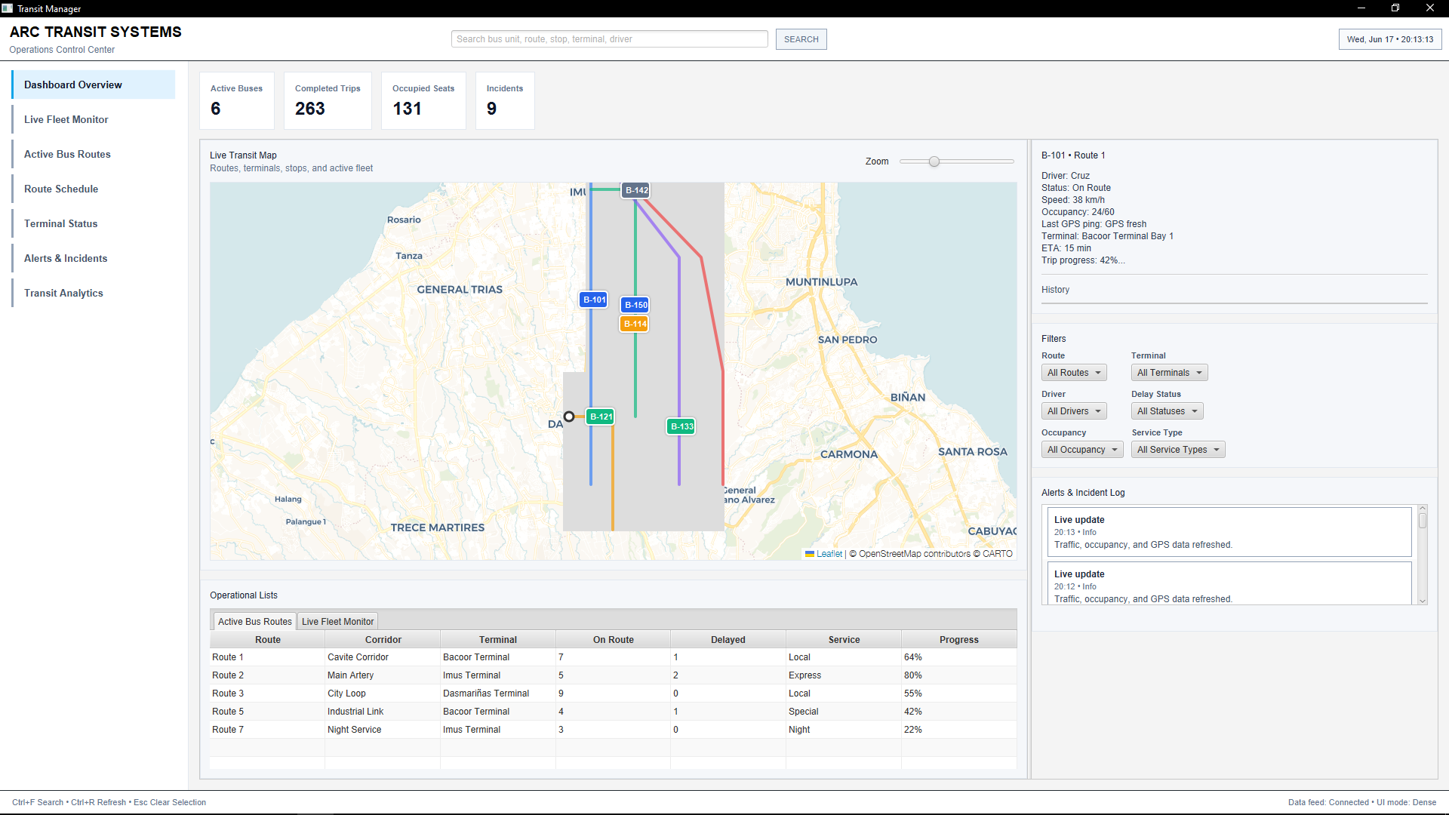

Conceptual Prototype User Flow Diagrams
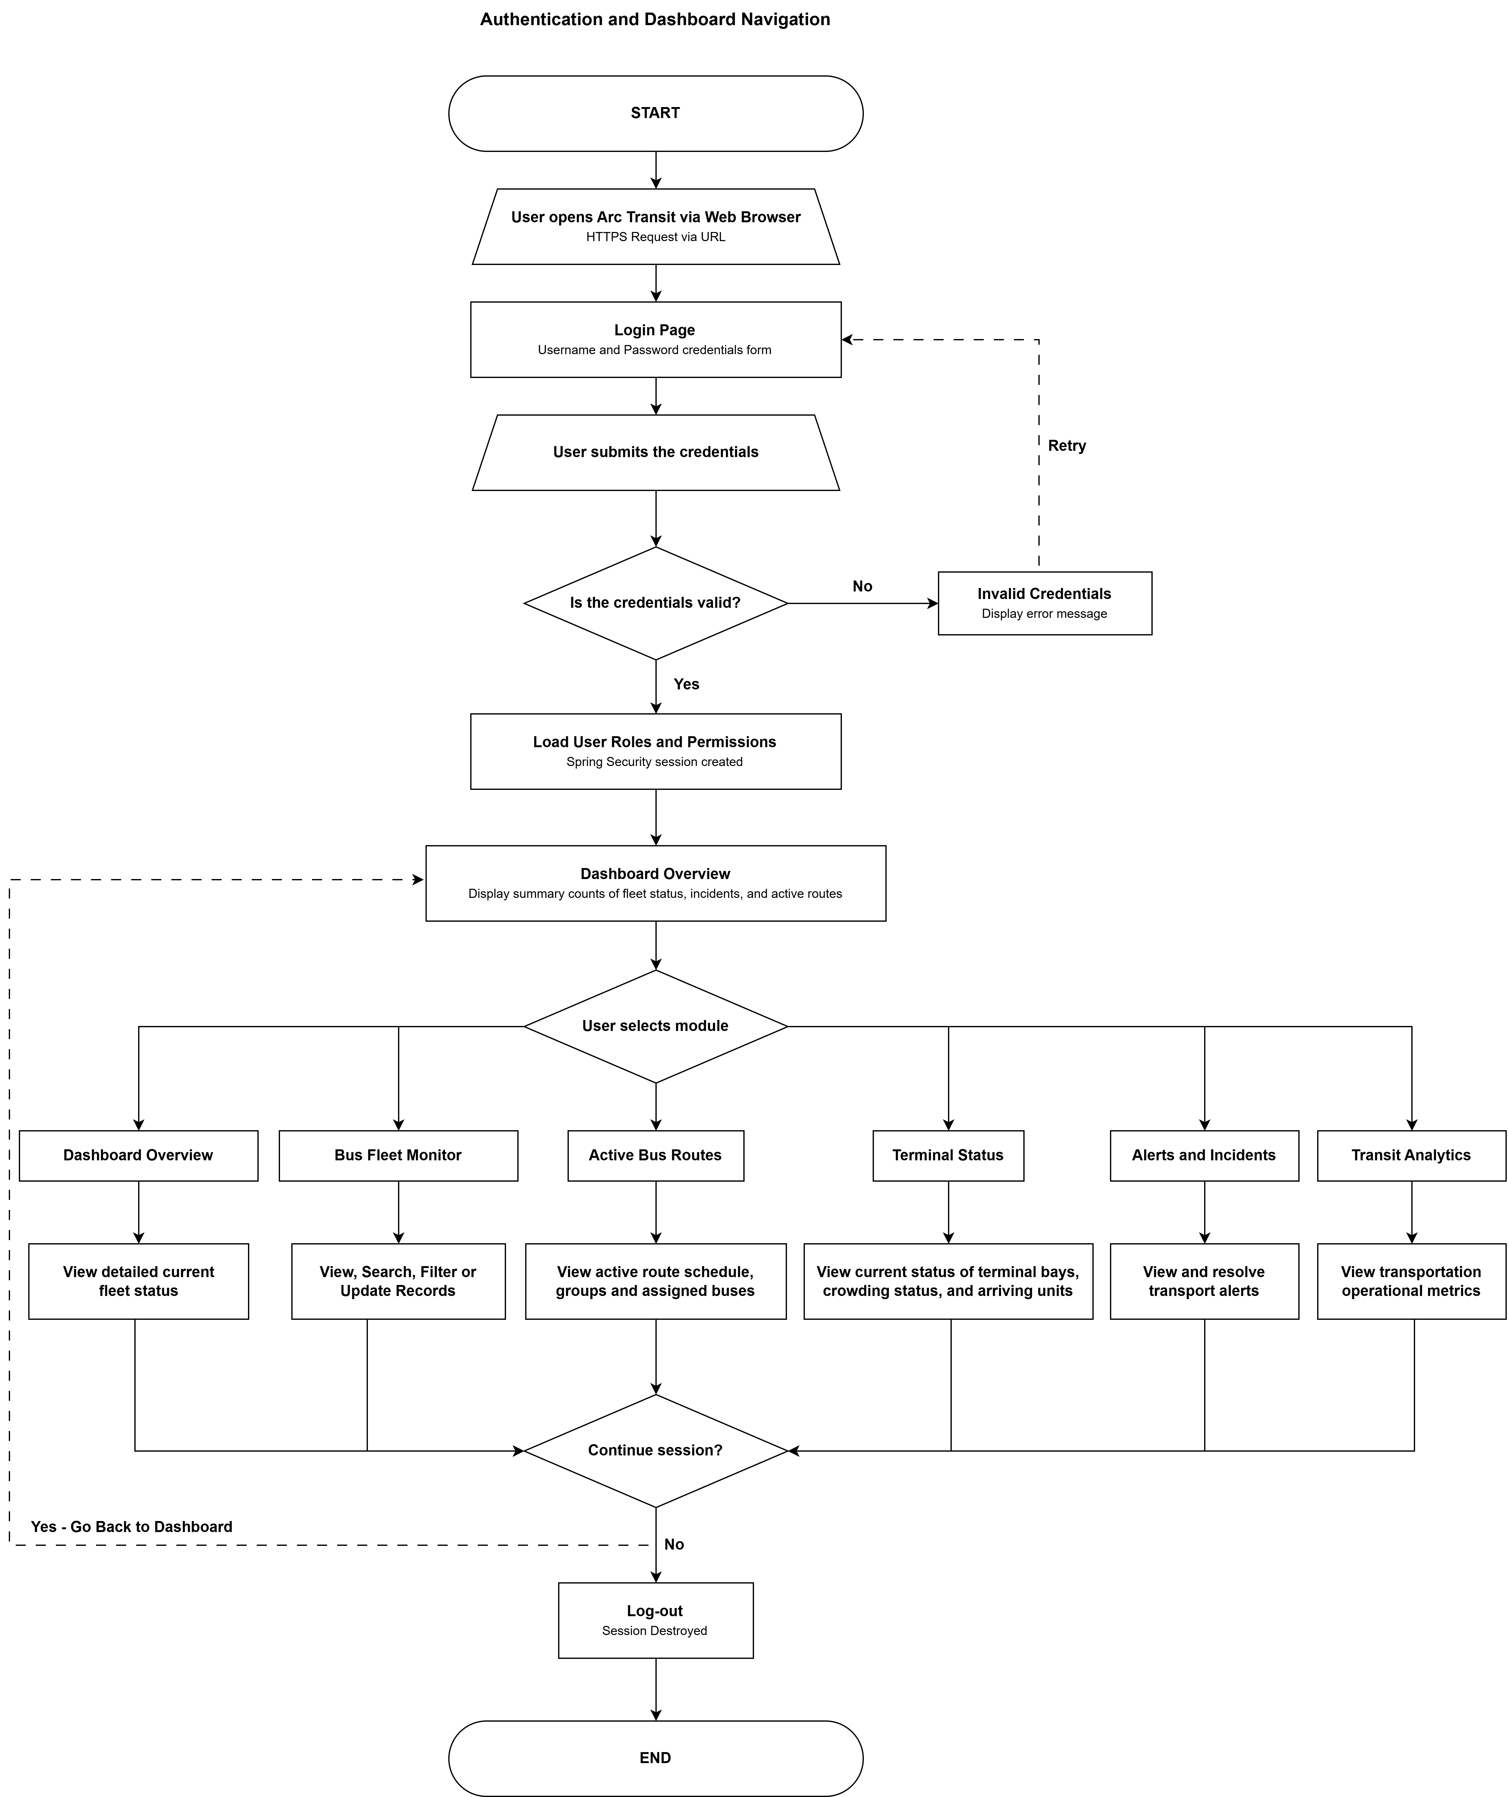

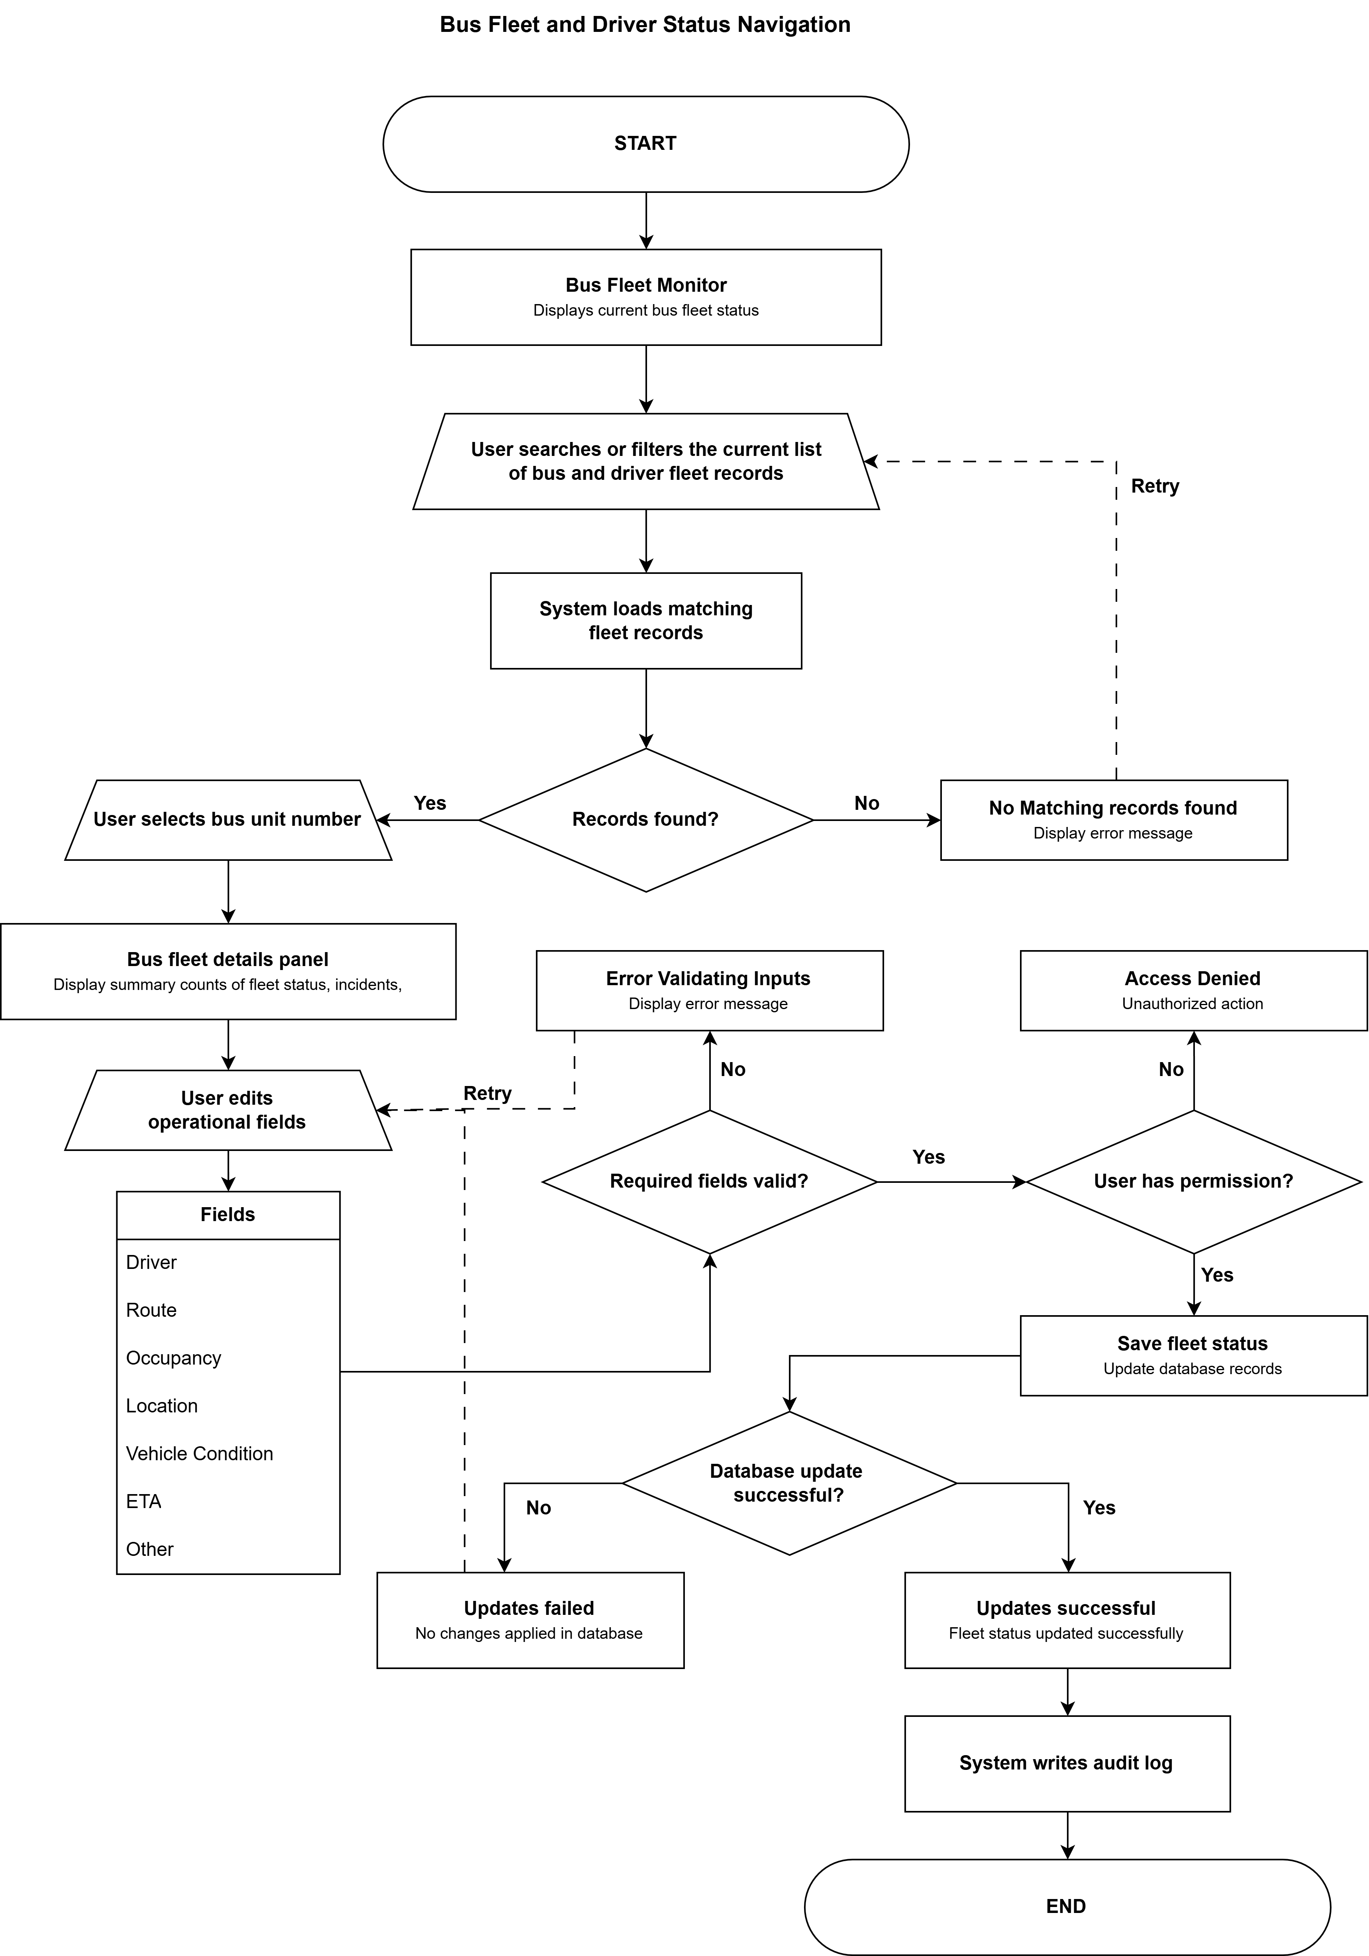
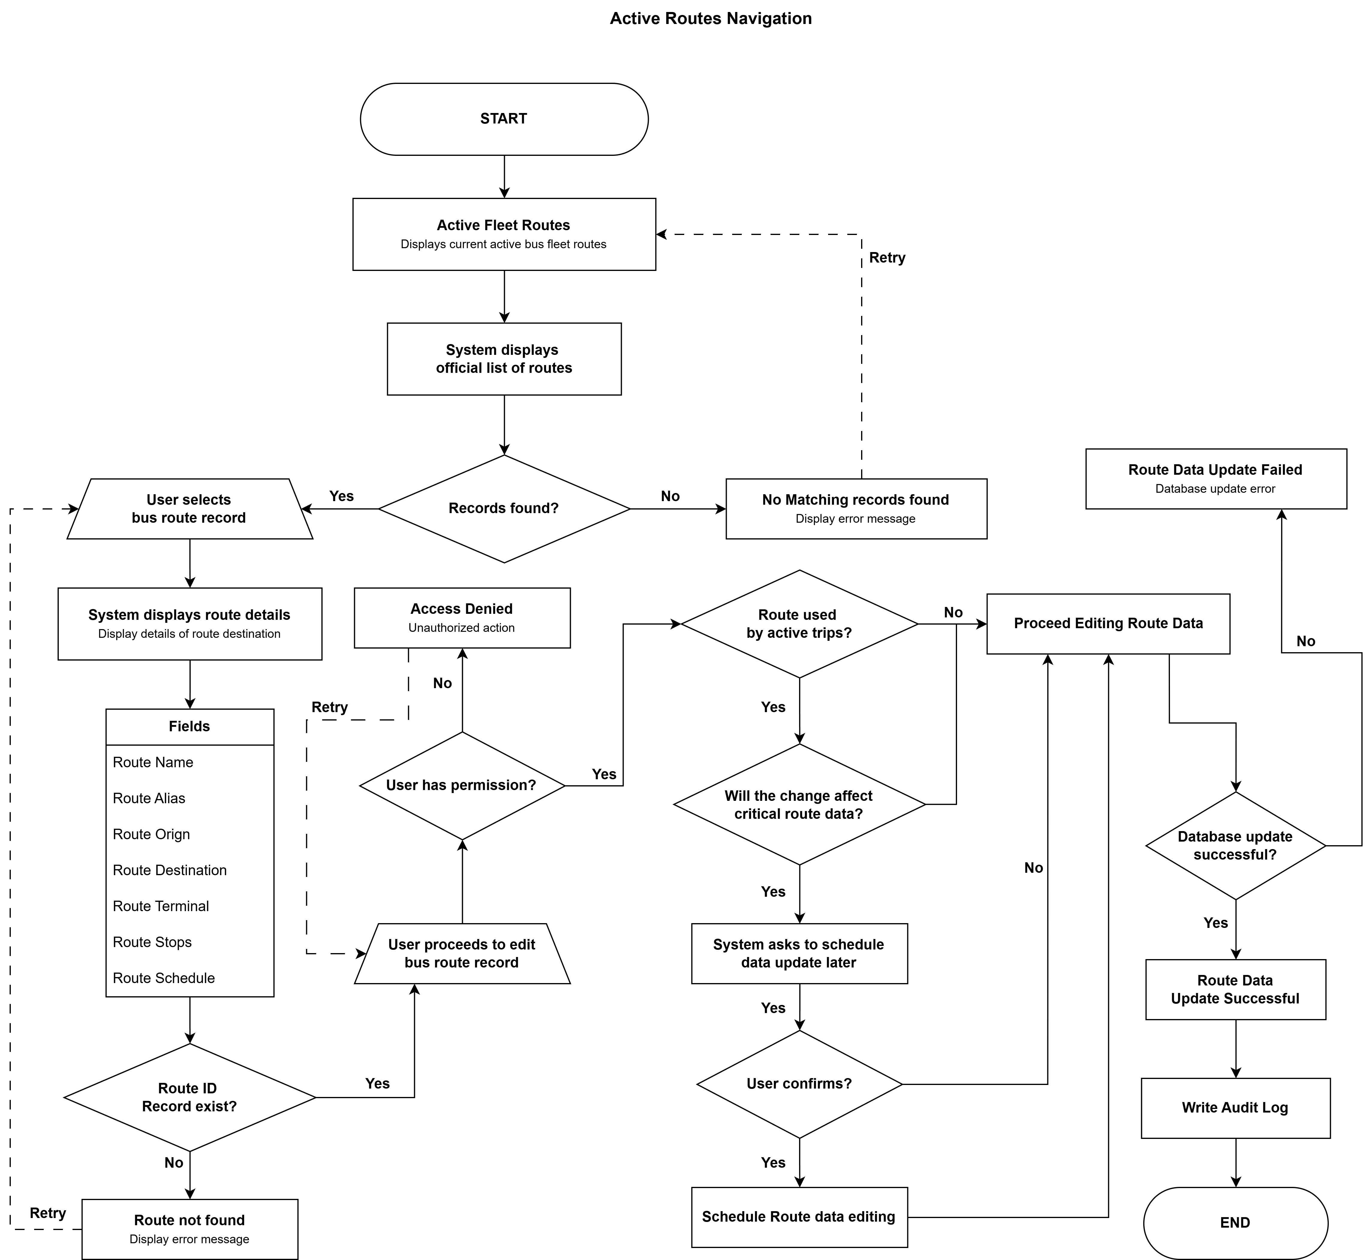

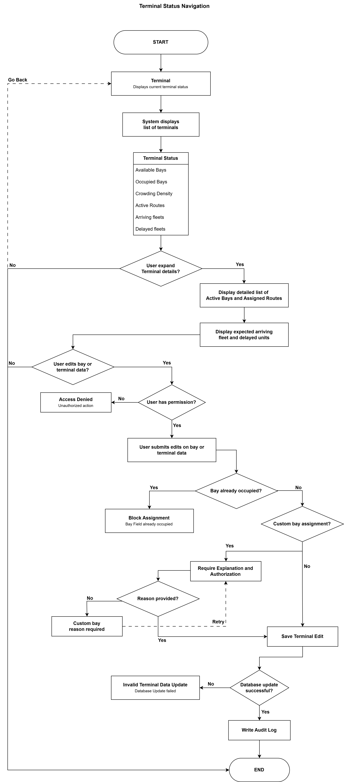
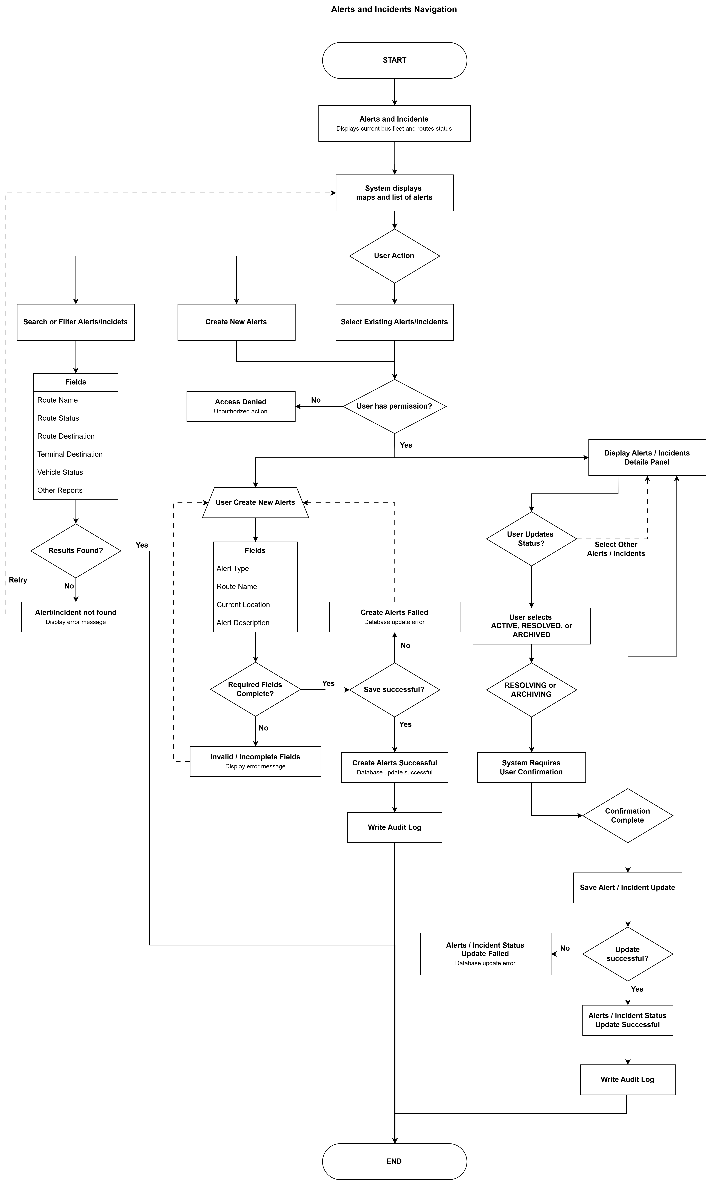
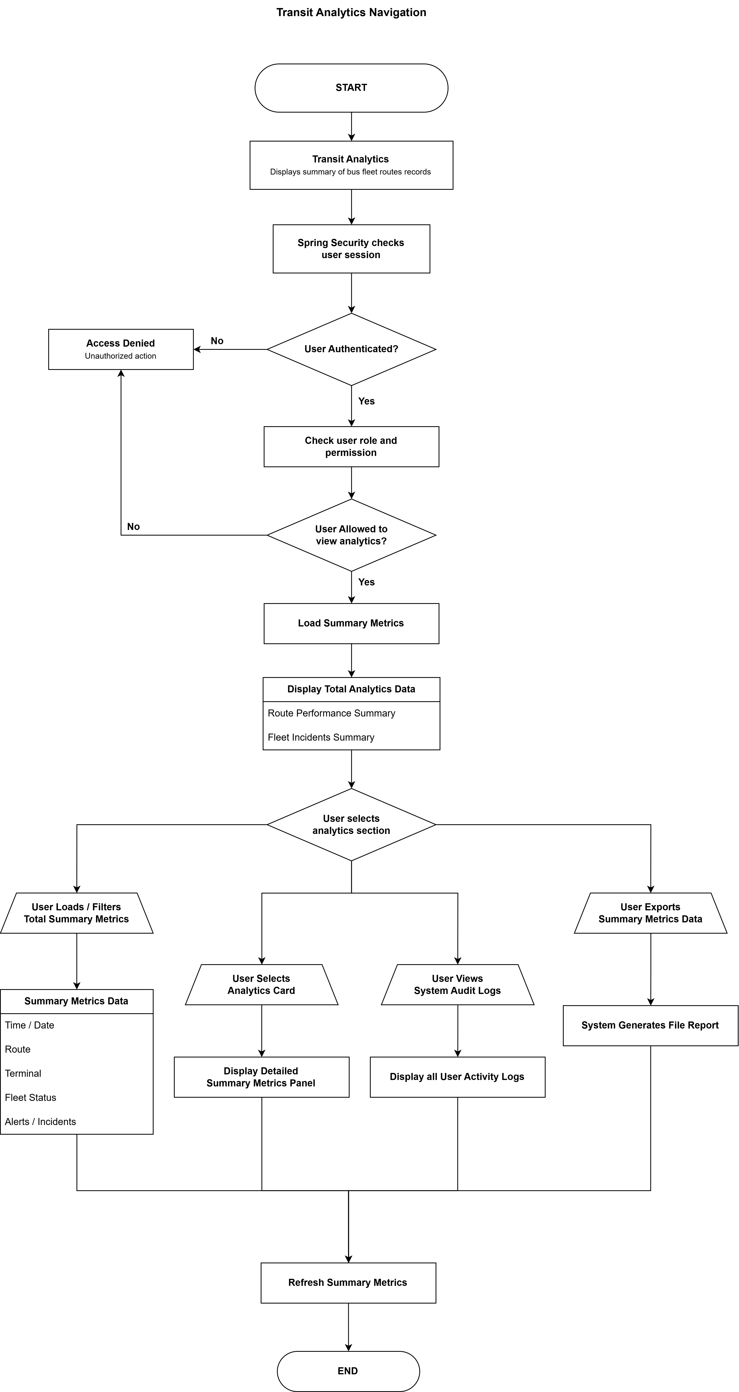

Design - System Architecture

Architecture Overview
Arc Transit uses a modular monolith architecture implemented with Spring Modulith. The application remains one deployable Spring Boot JAR, while domain modules are separated by explicit responsibilities and application-service interfaces. The architecture is centered on operational state integrity: planned service is separated from assigned service, field observations are stored as evidence-bearing records, verification and freshness are explicit, and reconciliation/exception logic produces an operational view without pretending that manually entered information is equivalent to telemetry.

RUNTIME FLOW
Web Browser → HTTPS → Spring Boot 4.1.0 and Vaadin Flow 25 → Spring Modulith 2.1.x modules → Spring Data JPA/JDBC → PostgreSQL. Operational observations, significant state changes, and audit events are retained historically where traceability is required.

Technology Stack
Technology | How the software is used
Java 21 | LTS baseline for the application, domain model, testing, and Vaadin UI. Vaadin 25 requires Java 21 or later [S14].
Spring Boot 4.1.0 | Current stable Spring Boot baseline verified against the official Spring documentation as of August 2026 [S13].
Spring Modulith 2.1.x | Module-boundary and application-module support inside a single deployable application. Stable 2.1.0 is documented in the current Spring Modulith release index [S15].
Vaadin Flow 25 | Server-side web UI baseline; current Vaadin guidance states Vaadin 25 uses Spring Boot 4 / Spring Framework 7 and requires Java 21+ [S14].
Spring Security | Session-based authentication and role checks for the browser application; security design remains server-side because the baseline has no separate public client.
PostgreSQL | Relational persistence for operational records, constraints, transactions, indexed queries, and append-only observation/state history.
Spring Data JPA / JDBC | JPA for transactional aggregates plus JDBC/explicit SQL for selected reconciliation, reporting, and aggregation queries where query visibility is important.
Flyway | Versioned SQL database migrations executed in a controlled order.
Maven | Build, test, dependency management, and packaging.
Docker Compose | Reproducible local deployment of the application and PostgreSQL services; cloud deployment remains a demonstration environment.

System Modules
Module | Main responsibility | Primary records or output
Auth | Staff accounts, roles, login access, and user administration. | app_users, roles, user_roles
Fleet | Fleet identity, authorized/administrative status, dispatchability, maintenance-blocked state, and operational observations. | fleet_units, fleet_status_updates
Driver | Driver identity, license validity, employment/availability state, and duty constraints. | drivers
Route | Fixed route definitions, route versions/effective periods, ordered stops, and recurring service templates. | routes, route_stops, route_schedules
Dispatch / Assignment | Dated service assignments, lifecycle state, vehicle/driver conflict checks, cancellation, replacement, and recovery traceability. | dispatch_assignments, audit_log state events
Operational State / Reconciliation | Captures field observations, source/provenance, verification, freshness, contradiction checks, reconciliation decisions, and exception generation. | fleet_status_updates and operational query projections
Incident | Operational incidents, severity, response workflow, affected service, actions, and resolution. | incidents
Maintenance | Scheduled/corrective work and availability effects; integrates maintenance state with dispatchability. | maintenance_records
Analytics | Read-only operational summaries, service-capacity views, exception queues, and quality indicators. | dashboard/query projections
Audit | Append-only business audit events and authorization outcomes. | audit_log

Architecture Decisions
The architecture decisions now follow the researched operating problem rather than attempting to imitate the infrastructure of a large transit operator. The modular monolith is retained because the core requirement is bounded operational coordination, not distributed scale. The main design addition is explicit operational evidence and reconciliation. Established systems demonstrate that telemetry, optimization, CAD/AVL, and integrated operations already exist at enterprise depth; Arc therefore focuses on integrity of manually or partially sourced operational state and on making uncertainty visible and actionable [S6][S7][S8][S9][S10][S11][S12].
Decision area | Selected approach | Alternatives considered and trade-off
Application architecture | Spring Modulith modular monolith. | Keeps deployment and operational complexity bounded while preserving module boundaries. Microservices are deferred because they do not solve the core research problem.
Operational model | Evidence-bearing state machine with explicit planned, assigned, observed, verified, stale, contradicted, and resolved states where appropriate. | A simple mutable status is easier to implement but cannot represent provenance, freshness, or recovery history.
Database | PostgreSQL. | Fits strongly relational operational records, transactional integrity, append-only histories, indexed queries, and reconciliation workloads.
Database migrations | Flyway ordered SQL migrations. | Keeps schema evolution reviewable and repeatable.
User interface | Vaadin Flow 25 inside Spring Boot 4.1.0. | Current Vaadin guidance aligns Vaadin 25 with Spring Boot 4 / Framework 7 and Java 21+ [S14].
Authentication and authorization | Spring Security with server-side sessions and role-based actions. | JWT is not required for the baseline because there is no separate public API client. OIDC can be evaluated if an external identity provider is introduced.
Data access | Spring Data JPA for transactional workflows plus JDBC/SQL for selected operational queries. | Explicit SQL is useful where reconciliation queries require precise visibility; avoid adding jOOQ/MyBatis unless measured complexity justifies them.
Module communication | Application-service interfaces and synchronous Spring application events. | Avoid Kafka/RabbitMQ in the baseline; use internal events for audit and non-return-value reactions.
Build/deployment | Maven, executable JAR, Docker, Docker Compose. | Kubernetes and distributed infrastructure remain out of scope until a real operational requirement exists.
Current runtime baseline | Java 21, Spring Boot 4.1.0, Spring Modulith 2.1.x, Vaadin 25. | The earlier Spring Boot 3.0 baseline is outdated for a new 2026 build plan. Current official sources list Spring Boot 4.1.0 as stable, and Vaadin 25 guidance requires Spring Boot 4 / Framework 7 with Java 21+ [S13][S14][S15].
Testing | JUnit 5, Spring Boot Test, Spring Modulith tests, PostgreSQL Testcontainers, API/service tests, security tests, state-transition tests, and controlled experiment scripts. | H2-only integration testing is insufficient for PostgreSQL-specific behaviour; test reconciliation rules against the actual database engine.

System Benchmarks
The benchmarks below are controlled prototype targets. Actual results must replace targets after implementation. Evaluation covers workflow and information-quality measures as well as software performance; no benchmark result is sufficient to claim city-scale transport improvement.
Seed-data profiles should include vehicles, drivers, route versions/stops/schedules, assignments, operational observations, incidents, maintenance records, exception cases, and audit records. The benchmark profile should be large enough to expose query behaviour but should not be interpreted as a simulation of an entire Philippine city network.

Metric | Target | Test conditions | Measurement method
Dashboard initial load | Under 3 seconds | Benchmark profile with 500 fleet records and representative operational observations; one authenticated session. | Browser Network panel after warm-up; repeat measurements and record median/p95.
User login | p95 under 500 ms | 50 concurrent virtual users in a controlled test environment. | k6 or JMeter test; record p50/p95/p99 and test conditions.
Fleet / exception search | p95 under 300 ms | 500 fleet records, 500+ observations, and measured exception/filter queries after warm-up. | Integration benchmark using PostgreSQL Testcontainers and a timing harness.
Route lookup | p95 under 300 ms | 50 route versions with configured stops/schedules and repeated lookups. | Measure application-service queries with PostgreSQL Testcontainers.
Operational update latency | Measure, do not predeclare success | Controlled timestamped observation submitted through the browser with known observation time. | Record observation time → recorded-at time → reconciliation time and report distributions.
Stale-state detection | Target 100% on defined injected cases | Deliberately create stale reports and contradictory states with known expected detections. | Compare injected defect set with generated exceptions; report false negatives and false positives.
Recovery traceability | Target 100% on defined injected cases | Inject cancellations, vehicle replacement, diversion, and maintenance substitution scenarios. | Verify incident → affected service → action → replacement → resolution chain remains reconstructable.
Audit completeness | Target 100% for controlled mutations | Exercise every defined state-changing workflow. | Verify actor, timestamp, entity, previous/new state or action, outcome, and correlation context.

System Flowchart

System Architecture Diagram
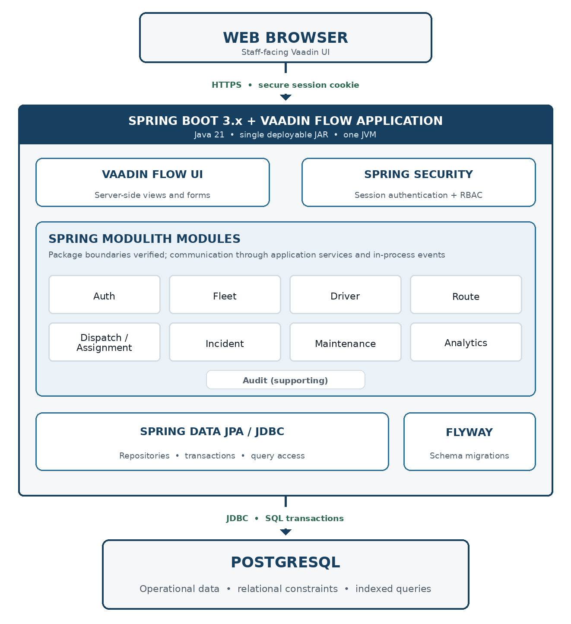

Design - Database Design

Entity Relationship Diagram (ERD)
The database design is shown in two logical diagrams so the relationships remain readable. Both diagrams describe one PostgreSQL database used by the same modular-monolith application.

Core Operations ERD
The core operations diagram shows how the main transit records connect. Fleet units, drivers, and route schedules meet in dispatch_assignments, which represents a vehicle and driver scheduled for a route on a specific service date. Fleet status updates preserve manually reported operating conditions. Incidents and maintenance records attach to the relevant route, assignment, or fleet unit so the system retains a complete operational history.
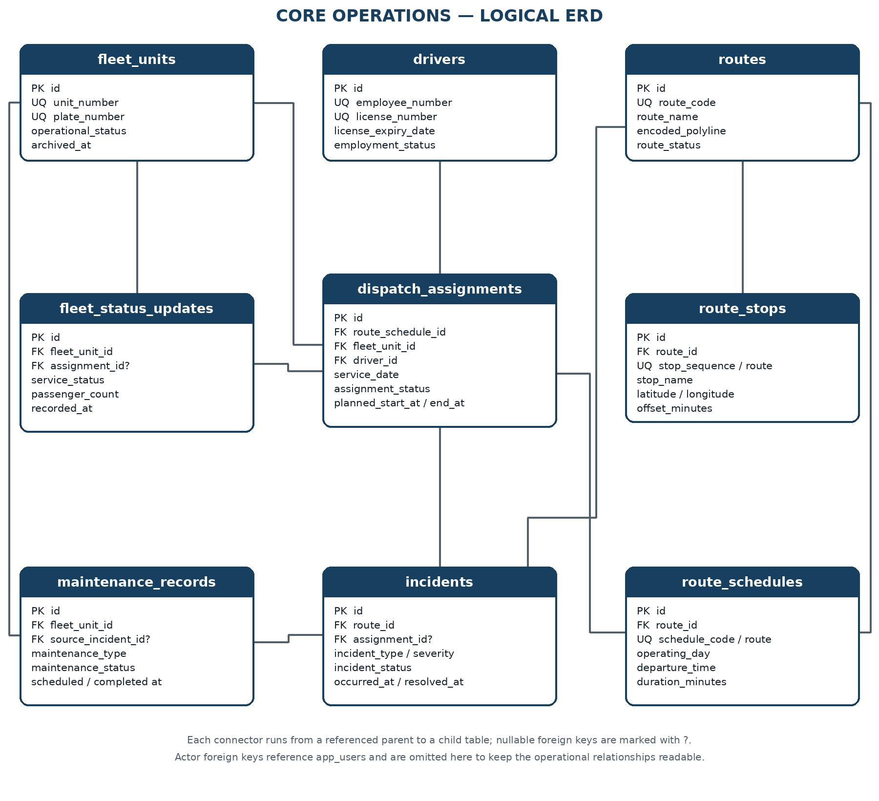

Security and Audit ERD
The security and audit diagram are separated because staff accounts and permissions support the application but are not transit-operation records. app_users stores authenticated staff accounts, roles and user_roles define whether the account is a System Admin or Operations Staff, and audit_log records who changed a business record, what action occurred, and when. Drivers remain operational records and do not automatically receive login accounts.
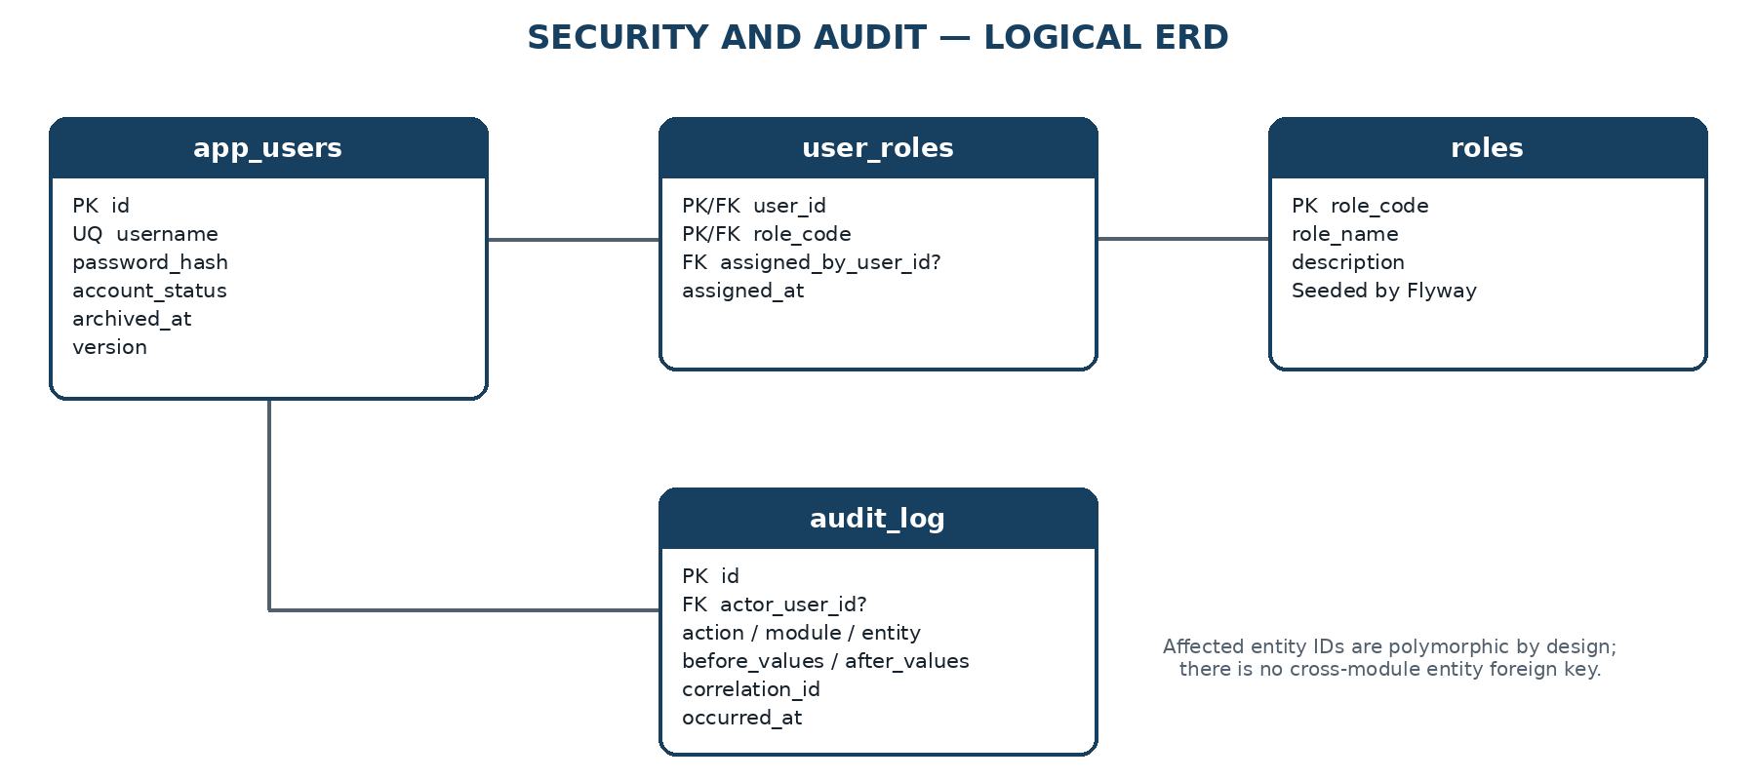
- Spring Security authenticates app_users through a server-side session.
- Drivers do not inherit user accounts. A staff account is created only when a person needs authorized browser access.
- The two role codes, SYSTEM_ADMIN and OPERATIONS_STAFF, are seeded by Flyway. Administrators assign roles to accounts but do not create new role definitions.
- audit_log stores important business changes and access outcomes. Technical request and error logs remain in the application log files.

Database Schema
PostgreSQL uses one application schema named arc. Tables are owned logically by Spring Modulith modules, but there is no schema-per-module or database-per-module split. The design is normalized for transactional integrity, while dashboard values are computed through indexed queries and read projections.
Module | Table | Responsibility
Auth | app_users | Authenticated staff accounts; drivers remain domain records, not login accounts.
Auth | roles | Seeded RBAC role codes used by Spring Security.
Auth | user_roles | Many-to-many assignment of staff accounts to roles.
Fleet | fleet_units | Bus-unit master data and current administrative availability state.
Fleet | fleet_status_updates | Append-only manual operational reports for location, load, delay, ETA, and vehicle condition.
Driver | drivers | Driver identity, license, and employment availability data.
Route | routes | Fixed route master data and optional encoded static-map polyline.
Route | route_stops | Ordered stop markers and coordinates for each fixed route.
Route | route_schedules | Recurring schedule templates by route, ISO weekday, departure time, and duration.
Dispatch | dispatch_assignments | Dated vehicle-and-driver assignment to a route schedule, including lifecycle timestamps.
Incident | incidents | Reported operational incidents, severity, workflow status, and resolution details.
Maintenance | maintenance_records | Scheduled or corrective work against a fleet unit, optionally originating from an incident.
Audit | audit_log | Append-only business audit events. Request logs remain structured application logs, not database rows.

Physical conventions
- Table and column names use lowercase snake_case. Java entities map explicitly to the arc schema.
- Entity keys use BIGINT identity columns. UUID is reserved for correlation_id, where distributed trace identity is useful.
- TIMESTAMPTZ stores instants in UTC. Asia/Manila is applied only when converting schedule templates and service dates for the UI.
- Mutable aggregates use a version column for optimistic locking. Manual fleet status and audit rows are append-only.
- VARCHAR plus named CHECK constraints is preferred over PostgreSQL enum types to keep state changes easy to migrate with Flyway.
- No PostGIS extension is required. Static maps use ordered stop coordinates and an optional encoded polyline.
- Flyway creates the arc schema and tables in dependency order. Demo reference data and simulated records are kept in separate migrations or profiles.

Data Dictionary
The dictionary below is the physical design baseline for Flyway and JPA mapping. Nullable means the database permits NULL; application services may impose stronger workflow rules before commit.

app_users
Column | PostgreSQL type | Null | Meaning / rule
id | BIGINT IDENTITY | No | Primary key.
username | VARCHAR(50) | No | Lowercase login name; unique.
password_hash | VARCHAR(100) | No | BCrypt hash only; never written to audit snapshots.
display_name | VARCHAR(120) | No | Human-readable staff name.
email | VARCHAR(254) | Yes | Optional contact address; case-insensitive unique when present.
account_status | VARCHAR(20) | No | ACTIVE, DISABLED, or LOCKED.
last_login_at | TIMESTAMPTZ | Yes | Most recent successful login.
created_at | TIMESTAMPTZ | No | Insert timestamp in UTC.
updated_at | TIMESTAMPTZ | No | Last modification timestamp in UTC.
archived_at | TIMESTAMPTZ | Yes | Soft-deactivation timestamp.
version | BIGINT | No | JPA optimistic-lock version.

roles
Column | PostgreSQL type | Null | Meaning / rule
role_code | VARCHAR(40) | No | Primary key, e.g. SYSTEM_ADMIN or OPERATIONS_STAFF.
role_name | VARCHAR(80) | No | Display label.
description | VARCHAR(255) | Yes | Permitted responsibility summary.

user_roles
Column | PostgreSQL type | Null | Meaning / rule
user_id | BIGINT | No | FK to app_users; composite primary key part.
role_code | VARCHAR(40) | No | FK to roles; composite primary key part.
assigned_by_user_id | BIGINT | Yes | FK to the administrator who granted the role.
assigned_at | TIMESTAMPTZ | No | Grant timestamp in UTC.

fleet_units
Column | PostgreSQL type | Null | Meaning / rule
id | BIGINT IDENTITY | No | Primary key.
unit_number | VARCHAR(30) | No | Internal fleet identifier; unique.
plate_number | VARCHAR(20) | No | Vehicle registration number; unique.
vehicle_type | VARCHAR(30) | No | Configured class such as BUS or MINIBUS.
capacity | SMALLINT | No | Maximum passenger count; greater than zero.
operational_status | VARCHAR(30) | No | ACTIVE, INACTIVE, UNDER_MAINTENANCE, or OUT_OF_SERVICE.
created_at | TIMESTAMPTZ | No | Insert timestamp in UTC.
updated_at | TIMESTAMPTZ | No | Last modification timestamp in UTC.
archived_at | TIMESTAMPTZ | Yes | Soft-delete timestamp; archived units cannot be dispatched.
version | BIGINT | No | JPA optimistic-lock version.

fleet_status_updates
Column | PostgreSQL type | Null | Meaning / rule
id | BIGINT IDENTITY | No | Primary key.
fleet_unit_id | BIGINT | No | FK to fleet_units.
assignment_id | BIGINT | Yes | FK to dispatch_assignments when the report is trip-specific.
service_status | VARCHAR(20) | No | NORMAL, DELAYED, INCIDENT, or OUT_OF_SERVICE.
passenger_count | SMALLINT | Yes | Manual count; non-negative. Capacity validation is performed by the service.
reported_location | VARCHAR(160) | Yes | Human-entered landmark, terminal, or stop; not GPS telemetry.
estimated_arrival_at | TIMESTAMPTZ | Yes | Optional manually supplied ETA.
fuel_level_percent | NUMERIC(5,2) | Yes | Manual value from 0 through 100.
engine_condition | VARCHAR(20) | No | NORMAL, WARNING, CRITICAL, or UNKNOWN.
tire_condition | VARCHAR(20) | No | NORMAL, WARNING, CRITICAL, or UNKNOWN.
notes | VARCHAR(1000) | Yes | Traffic, delay, or operational remarks.
submitted_by_user_id | BIGINT | No | FK to the staff account that submitted the report.
recorded_at | TIMESTAMPTZ | No | Operational observation time.
created_at | TIMESTAMPTZ | No | Database insert time; records are append-only.
source_type | VARCHAR(20) | No | MANUAL, IMPORTED, SYSTEM, or TELEMETRY when an external feed is later integrated.
verification_status | VARCHAR(30) | No | UNVERIFIED, OPERATOR_CONFIRMED, SUPERVISOR_VERIFIED, or SYSTEM_VERIFIED; verification does not by itself prove physical truth.
observed_at | TIMESTAMPTZ | No | Time the operational condition was observed; distinct from database creation time.
verified_by_user_id | BIGINT | Yes | Staff account that performed a verification action, when applicable.
verified_at | TIMESTAMPTZ | Yes | Time the observation was verified, when applicable.

drivers
Column | PostgreSQL type | Null | Meaning / rule
id | BIGINT IDENTITY | No | Primary key.
employee_number | VARCHAR(30) | No | Internal driver identifier; unique.
first_name | VARCHAR(80) | No | Given name.
last_name | VARCHAR(80) | No | Family name.
license_number | VARCHAR(40) | No | Driver-license identifier; unique.
license_class | VARCHAR(20) | No | Configured license classification.
license_expiry_date | DATE | No | Expired licenses fail dispatch validation.
employment_status | VARCHAR(20) | No | ACTIVE, INACTIVE, SUSPENDED, or ON_LEAVE.
contact_number | VARCHAR(30) | Yes | Optional operational contact.
created_at | TIMESTAMPTZ | No | Insert timestamp in UTC.
updated_at | TIMESTAMPTZ | No | Last modification timestamp in UTC.
archived_at | TIMESTAMPTZ | Yes | Soft-delete timestamp.
version | BIGINT | No | JPA optimistic-lock version.

routes
Column | PostgreSQL type | Null | Meaning / rule
id | BIGINT IDENTITY | No | Primary key.
route_code | VARCHAR(30) | No | Stable route identifier; unique.
route_name | VARCHAR(120) | No | Human-readable route name.
origin_name | VARCHAR(120) | No | Configured origin.
destination_name | VARCHAR(120) | No | Configured destination.
encoded_polyline | TEXT | Yes | Static map path; no live position data and no PostGIS dependency.
route_status | VARCHAR(20) | No | ACTIVE or INACTIVE.
created_at | TIMESTAMPTZ | No | Insert timestamp in UTC.
updated_at | TIMESTAMPTZ | No | Last modification timestamp in UTC.
archived_at | TIMESTAMPTZ | Yes | Soft-delete timestamp.
version | BIGINT | No | JPA optimistic-lock version.
version_number | INTEGER | No | Route-definition version used to preserve service meaning over time; greater than zero.
effective_from | DATE | No | First service date for which this route definition is effective.
effective_to | DATE | Yes | Last service date for which this route definition is effective; NULL means open-ended.

route_stops
Column | PostgreSQL type | Null | Meaning / rule
id | BIGINT IDENTITY | No | Primary key.
route_id | BIGINT | No | FK to routes.
stop_sequence | SMALLINT | No | One-based order within the route.
stop_code | VARCHAR(30) | Yes | Optional operator-specific stop identifier.
stop_name | VARCHAR(120) | No | Map marker label.
latitude | NUMERIC(9,6) | No | Static latitude from -90 through 90.
longitude | NUMERIC(9,6) | No | Static longitude from -180 through 180.
offset_minutes | SMALLINT | Yes | Planned minutes from route departure; non-negative.
created_at | TIMESTAMPTZ | No | Insert timestamp in UTC.
updated_at | TIMESTAMPTZ | No | Last modification timestamp in UTC.
version | BIGINT | No | JPA optimistic-lock version.

route_schedules
Column | PostgreSQL type | Null | Meaning / rule
id | BIGINT IDENTITY | No | Primary key.
route_id | BIGINT | No | FK to routes.
schedule_code | VARCHAR(30) | No | Stable code unique within a route.
operating_day | SMALLINT | No | ISO weekday: 1 Monday through 7 Sunday.
departure_time | TIME | No | Local scheduled departure in Asia/Manila.
duration_minutes | SMALLINT | No | Planned positive duration; supports trips crossing midnight.
active | BOOLEAN | No | Whether new dated assignments may use the template.
created_at | TIMESTAMPTZ | No | Insert timestamp in UTC.
updated_at | TIMESTAMPTZ | No | Last modification timestamp in UTC.
version | BIGINT | No | JPA optimistic-lock version.

dispatch_assignments
Column | PostgreSQL type | Null | Meaning / rule
id | BIGINT IDENTITY | No | Primary key.
assignment_code | VARCHAR(30) | No | Human-readable reference; unique.
route_schedule_id | BIGINT | No | FK to route_schedules.
fleet_unit_id | BIGINT | No | FK to fleet_units.
driver_id | BIGINT | No | FK to drivers.
service_date | DATE | No | Operating date in Asia/Manila.
planned_start_at | TIMESTAMPTZ | No | Resolved schedule start instant.
planned_end_at | TIMESTAMPTZ | No | Resolved schedule end instant.
actual_start_at | TIMESTAMPTZ | Yes | Recorded dispatch/start time.
actual_end_at | TIMESTAMPTZ | Yes | Recorded completion time.
assignment_status | VARCHAR(20) | No | PLANNED, DISPATCHED, IN_SERVICE, COMPLETED, or CANCELLED.
assigned_by_user_id | BIGINT | No | FK to the dispatcher or administrator.
cancellation_reason | VARCHAR(500) | Yes | Required by the service when status becomes CANCELLED.
notes | VARCHAR(1000) | Yes | Dispatch remarks.
created_at | TIMESTAMPTZ | No | Insert timestamp in UTC.
updated_at | TIMESTAMPTZ | No | Last modification timestamp in UTC.
version | BIGINT | No | JPA optimistic-lock version.

incidents
Column | PostgreSQL type | Null | Meaning / rule
id | BIGINT IDENTITY | No | Primary key.
incident_number | VARCHAR(30) | No | Human-readable incident reference; unique.
route_id | BIGINT | No | FK to the affected route.
assignment_id | BIGINT | Yes | FK to a trip when the incident is assignment-specific.
incident_type | VARCHAR(30) | No | DELAY, BREAKDOWN, ACCIDENT, SECURITY, MEDICAL, or OTHER.
severity | VARCHAR(20) | No | LOW, MEDIUM, HIGH, or CRITICAL.
incident_status | VARCHAR(20) | No | OPEN, ACKNOWLEDGED, IN_PROGRESS, RESOLVED, or CLOSED.
description | VARCHAR(2000) | No | Operational facts reported by staff.
occurred_at | TIMESTAMPTZ | No | Reported event time.
reported_at | TIMESTAMPTZ | No | Submission time.
resolved_at | TIMESTAMPTZ | Yes | Required for RESOLVED or CLOSED status.
resolution_notes | VARCHAR(2000) | Yes | Required by the service before closure.
reported_by_user_id | BIGINT | No | FK to reporting staff account.
assigned_to_user_id | BIGINT | Yes | Optional owner responsible for resolution.
created_at | TIMESTAMPTZ | No | Insert timestamp in UTC.
updated_at | TIMESTAMPTZ | No | Last modification timestamp in UTC.
version | BIGINT | No | JPA optimistic-lock version.

maintenance_records
Column | PostgreSQL type | Null | Meaning / rule
id | BIGINT IDENTITY | No | Primary key.
maintenance_number | VARCHAR(30) | No | Human-readable work reference; unique.
fleet_unit_id | BIGINT | No | FK to the unit receiving service.
source_incident_id | BIGINT | Yes | Optional FK to the incident that triggered the work.
maintenance_type | VARCHAR(30) | No | INSPECTION, PREVENTIVE, CORRECTIVE, or REPAIR.
maintenance_status | VARCHAR(20) | No | SCHEDULED, IN_PROGRESS, COMPLETED, or CANCELLED.
summary | VARCHAR(200) | No | Short work description.
details | VARCHAR(2000) | Yes | Inspection findings or repair notes.
scheduled_start_at | TIMESTAMPTZ | Yes | Planned service time.
started_at | TIMESTAMPTZ | Yes | Actual start time.
completed_at | TIMESTAMPTZ | Yes | Required when status is COMPLETED.
handled_by_user_id | BIGINT | Yes | FK to maintenance staff owner.
created_by_user_id | BIGINT | No | FK to the staff account that opened the record.
created_at | TIMESTAMPTZ | No | Insert timestamp in UTC.
updated_at | TIMESTAMPTZ | No | Last modification timestamp in UTC.
version | BIGINT | No | JPA optimistic-lock version.

audit_log
Column | PostgreSQL type | Null | Meaning / rule
id | BIGINT IDENTITY | No | Primary key; monotonically increasing storage identity.
actor_user_id | BIGINT | Yes | FK to app_users; null only for controlled system events.
actor_username | VARCHAR(50) | No | Immutable username snapshot; SYSTEM for controlled system events.
action_type | VARCHAR(50) | No | Business action such as ASSIGNMENT_CREATED or STATUS_CHANGED.
module_name | VARCHAR(40) | No | Owning application module.
entity_type | VARCHAR(60) | No | Affected aggregate type.
entity_id | VARCHAR(64) | No | Affected record identifier; intentionally polymorphic.
outcome | VARCHAR(20) | No | SUCCESS, DENIED, or FAILED.
correlation_id | UUID | No | Request or use-case correlation identifier.
request_method | VARCHAR(10) | Yes | Optional HTTP method context.
request_path | VARCHAR(500) | Yes | Optional Vaadin/request path context.
response_status | SMALLINT | Yes | Optional HTTP response status.
before_values | JSONB | Yes | Whitelisted changed fields before the action; no secrets.
after_values | JSONB | Yes | Whitelisted changed fields after the action; no secrets.
ip_address | INET | Yes | Optional request source address.
occurred_at | TIMESTAMPTZ | No | Immutable event time in UTC.

Relationships
Foreign keys preserve module ownership without converting the modular monolith into distributed services. Cross-module writes are coordinated by application services. State-changing workflows emit audit/domain events so the system retains the difference between current state and the evidence/history that produced it.
- app_users and roles have a many-to-many relationship through user_roles. Role rows are reference data seeded by Flyway.
- fleet_units has many fleet_status_updates, dispatch_assignments, and maintenance_records. The fleet model separates administrative availability from dispatchability and field-reported operating condition. Master rows are archived instead of hard-deleted.
- drivers has many dispatch_assignments. A driver is a managed domain entity and is not automatically an app_users account.
- routes have version/effective-period information, ordered stops, recurring schedules, and incidents. Versioning preserves the meaning of historical assignments when route structures are modified or rationalized.
- route_schedules remain reusable templates, while dated dispatch_assignments represent actual service instances. A schedule template can remain stable while individual service dates are cancelled, curtailed, diverted, replaced, or completed.
- dispatch_assignments belongs to one route schedule/version context, fleet unit, and driver. It may have many manual observations and incidents. Assignment state changes and significant workflow actions are preserved through audit/state events so recovery can be reconstructed.
- incidents may reference one dispatch assignment and may originate zero or more maintenance records. A route remains mandatory for reporting and aggregation.
- audit_log references app_users only for the actor. Its entity_type/entity_id pair is deliberately not a foreign key because one audit table covers multiple modules.
- Analytics owns no mutable operational facts. Dashboard counts and exception values are projections over assignments, the latest relevant observation, open incidents, maintenance state, route versions, freshness rules, verification status, and reconciliation outcomes.

Indexes
Indexes are limited to uniqueness rules and demonstrated query paths. PostgreSQL primary-key indexes are implicit and are not repeated below. Index names shown here are the intended Flyway names; final EXPLAIN ANALYZE results may justify adjustment.
Table | Index | Columns / predicate | Purpose
app_users | ux_users_username | Username | Case-normalized login uniqueness.
app_users | ux_users_email | lower(email) WHERE email IS NOT NULL | Optional email uniqueness.
fleet_units | ux_fleet_unit_number | unit_number | Direct unit lookup and uniqueness.
fleet_units | ux_fleet_plate_number | plate_number | Plate lookup and uniqueness.
fleet_units | ix_fleet_active_status | operational_status WHERE archived_at IS NULL | Fleet filter and dashboard counts.
fleet_status_updates | ix_status_unit_recorded | fleet_unit_id, recorded_at DESC | Latest report for a unit.
fleet_status_updates | ix_status_service_recorded | service_status, recorded_at DESC | Delayed/out-of-service dashboard queries.
drivers | ux_driver_employee_no | employee_number | Direct driver lookup and uniqueness.
drivers | ux_driver_license_no | license_number | License uniqueness.
drivers | ix_driver_employment | employment_status WHERE archived_at IS NULL | Dispatch availability filter.
routes | ux_route_code | route_code | Direct route lookup and uniqueness.
routes | ix_route_active | route_status WHERE archived_at IS NULL | Active route list.
route_stops | ux_stop_route_sequence | route_id, stop_sequence | Stable stop ordering.
route_schedules | ux_schedule_code | route_id, schedule_code | Schedule-template uniqueness.
route_schedules | ix_schedule_lookup | route_id, operating_day, departure_time WHERE active = TRUE | Daily schedule selection.
dispatch_assignments | ux_assignment_code | assignment_code | Direct reference lookup.
dispatch_assignments | ux_active_schedule_date | route_schedule_id, service_date WHERE assignment_status <> 'CANCELLED' | One active assignment per schedule instance.
dispatch_assignments | ix_assignment_vehicle_window | fleet_unit_id, planned_start_at, planned_end_at WHERE assignment_status IN ('PLANNED', 'DISPATCHED', 'IN_SERVICE') | Vehicle overlap check.
dispatch_assignments | ix_assignment_driver_window | driver_id, planned_start_at, planned_end_at WHERE assignment_status IN ('PLANNED', 'DISPATCHED', 'IN_SERVICE') | Driver overlap check.
dispatch_assignments | ix_assignment_service_status | service_date, assignment_status | Operations board and daily counts.
incidents | ux_incident_number | incident_number | Direct incident lookup.
incidents | ix_incident_open_queue | incident_status, severity, occurred_at DESC | Prioritized unresolved incident queue.
incidents | ix_incident_route_time | route_id, occurred_at DESC | Route incident history.
maintenance_records | ux_maintenance_number | maintenance_number | Direct work-record lookup.
maintenance_records | ix_maintenance_unit_status | fleet_unit_id, maintenance_status | Unit maintenance history and active work.
maintenance_records | ix_maintenance_schedule | scheduled_start_at WHERE maintenance_status = 'SCHEDULED' | Upcoming maintenance list.
audit_log | ix_audit_entity_time | entity_type, entity_id, occurred_at DESC | Affected-record audit history.
audit_log | ix_audit_actor_time | actor_user_id, occurred_at DESC | User activity review.
audit_log | ix_audit_correlation | correlation_id | Trace one use case across audit events.

Index validation rule
Fleet search and dispatch conflict queries must be checked with EXPLAIN (ANALYZE, BUFFERS) against the seeded benchmark dataset. Unused or redundant indexes are removed before the portfolio release because every additional index increases write cost.

Constraints
Database constraints protect facts that are always invalid, while application services enforce workflow rules that require current state, permissions, cross-table comparison, freshness logic, or reconciliation decisions. This keeps core integrity in the database without turning PostgreSQL into a full workflow engine.

Identity and deletion
- BIGINT GENERATED BY DEFAULT AS IDENTITY is used for entity primary keys; roles uses role_code and user_roles uses a composite key. Operational observation/state-history identities are immutable once created.
- fleet_units, drivers, routes, and app_users use archived_at for reversible deactivation. Transactional and audit history is not hard-deleted by normal application flows. Corrections are represented by compensating events or audit entries.
- Foreign keys use RESTRICT for operational ownership and SET NULL only for optional actor/assignee references where history must survive account retirement.

Controlled states
- Lifecycle columns use VARCHAR plus named CHECK constraints. Application services define valid state transitions for fleet dispatchability, assignment/trip lifecycle, incidents, maintenance, verification, and reconciliation. The database rejects unknown terminal values but does not encode the entire workflow graph.
- Role codes are limited to SYSTEM_ADMIN and OPERATIONS_STAFF.
- The service layer owns valid state transitions; database CHECK constraints reject unknown terminal values but do not attempt to encode the full workflow graph.

Numeric and temporal integrity
- capacity must be greater than zero; passenger_count and other measured quantities cannot be negative; static coordinates must be valid; planned and actual time fields must be chronologically consistent. Observation time and recording time are stored separately so stale or delayed submissions can be measured.
- Static stop coordinates are constrained to valid latitude and longitude ranges. No telemetry or geospatial extension is introduced.
- planned_end_at must be later than planned_start_at; actual_end_at cannot precede actual_start_at; completed maintenance and resolved incidents require completion timestamps.
- All instants use TIMESTAMPTZ and are stored in UTC. service_date and schedule time are interpreted in Asia/Manila before conversion to an instant.

Dispatch conflict handling
- The assignment service rejects archived/unavailable/non-dispatchable units, inactive schedules, invalid drivers, overlapping active assignments, and other known conflicts before commit. PostgreSQL uniqueness and indexed time-window checks remain the baseline; stronger exclusion constraints may be evaluated only if measured concurrency requirements justify them.
- Driver and vehicle overlap checks run inside the assignment application service using indexed time-window queries and optimistic locking. For this single-dispatcher portfolio scope, a PostgreSQL btree_gist exclusion constraint is intentionally deferred.
- The assignment service rejects archived/unavailable units, inactive or unlicensed drivers, inactive schedules, and overlapping active assignments before commit.
- For redundant operational context, the service verifies that a fleet status update references the same fleet unit as its assignment and that an incident route matches its referenced assignment route.

Audit and privacy
- audit_log is append-only from the application perspective. Operational observations also preserve source and verification metadata. Audit JSON contains only whitelisted changed fields and must never include password hashes or unnecessary personal data. Audit history proves recorded actions, not the physical truth of a manual report.
- Audit JSON contains only whitelisted changed fields. Password hashes, session identifiers, secrets, and full sensitive payloads are never persisted in before_values or after_values.
- Every business status change and dispatch action creates an audit event in the same transaction. General authenticated-request logs are emitted as structured application logs to avoid unbounded database growth.

Design - Application Service Contracts

Application Service Boundary
The Java application-service interfaces form the boundary between Vaadin views and the Spring Modulith domain modules. Vaadin views submit commands and queries to these services, while repositories and JPA entities remain internal to the module that owns them. This keeps business rules in one testable application layer and prevents UI code from bypassing module boundaries.
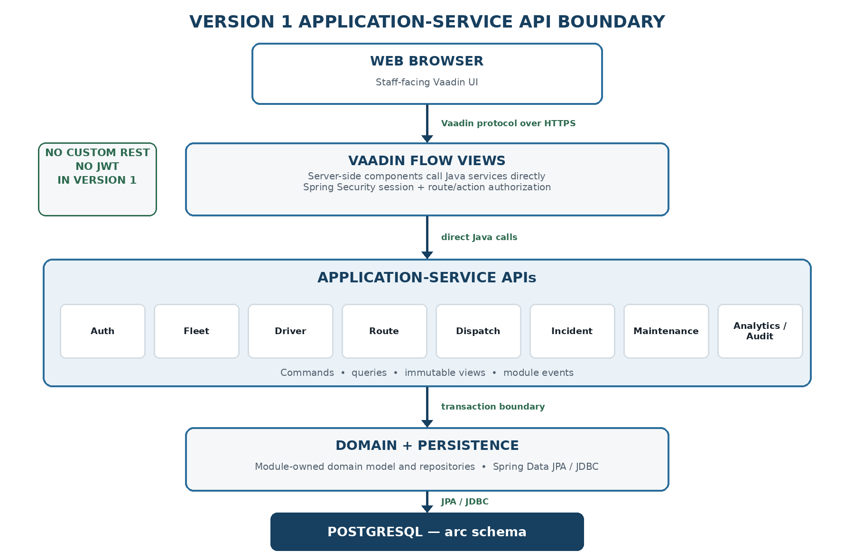
Figure 5.1 — Vaadin-to-application-service interaction boundary.
- Vaadin views inject service interfaces and exchange commands, queries, and immutable view records.
- Views never access Spring Data repositories or expose JPA entities directly.
- Spring Security enforces route access and method-level authorization; services remain the authoritative action boundary.

Authentication and User Administration
Spring Security owns login, logout, session creation, CSRF protection, and navigation access. There is no custom login API. UserAdministrationService covers only account and role-management use cases.
Operation | Java contract | Allowed roles | Key rule
Current user | CurrentUserView currentUser() | Authenticated | Read-only session principal and effective roles.
Search users | Page<UserSummaryView> searchUsers(UserQuery, Pageable) | SYSTEM_ADMIN | Read-only; never returns password hashes.
Create user | UserView createUser(CreateUserCommand) | SYSTEM_ADMIN | Hashes the supplied password and writes an audit event.
Account status | UserView changeAccountStatus(ChangeAccountStatusCommand) | SYSTEM_ADMIN | ACTIVE, DISABLED, or LOCKED; requires expectedVersion.
Replace roles | UserView replaceRoles(ReplaceUserRolesCommand) | SYSTEM_ADMIN | Validates seeded role codes; audited in the same transaction.

Fleet Application Service
FleetApplicationService manages fleet master data and append-only manual status submissions. Administrative status and trip status remain distinct: fleet_units stores dispatchability, while fleet_status_updates stores operational observations.
Operation | Java contract | Allowed roles | Key rule
Create unit | FleetUnitView createUnit(CreateFleetUnitCommand) | SYSTEM_ADMIN | Validates unique unit and plate numbers.
Update unit | FleetUnitView updateUnit(UpdateFleetUnitCommand) | SYSTEM_ADMIN | Requires expectedVersion; rejects stale writes.
Archive unit | void archiveUnit(ArchiveFleetUnitCommand) | SYSTEM_ADMIN | Rejected while an active assignment or maintenance rule blocks archival.
Get unit | FleetUnitView getUnit(long unitId) | SYSTEM_ADMIN, OPERATIONS_STAFF | Read-only; excludes archived rows unless explicitly requested.
Search units | Page<FleetUnitSummaryView> searchUnits(FleetQuery, Pageable) | SYSTEM_ADMIN, OPERATIONS_STAFF | Filters status, unit number, plate number, and vehicle type.
Submit status | FleetStatusView submitStatus(SubmitFleetStatusCommand) | SYSTEM_ADMIN, OPERATIONS_STAFF | Append-only; validates assignment and fleet-unit consistency.
Latest status | Optional<FleetStatusView> latestStatus(long unitId) | SYSTEM_ADMIN, OPERATIONS_STAFF | Uses fleet_unit_id + recorded_at descending index.

Driver Application Service
DriverApplicationService owns driver identity, license, employment state, archival, and dispatch-availability checks. Drivers are domain records, not authenticated accounts.
Operation | Java contract | Allowed roles | Key rule
Create driver | DriverView createDriver(CreateDriverCommand) | SYSTEM_ADMIN | Validates employee and license-number uniqueness.
Update driver | DriverView updateDriver(UpdateDriverCommand) | SYSTEM_ADMIN | Requires expectedVersion.
Archive driver | void archiveDriver(ArchiveDriverCommand) | SYSTEM_ADMIN | Rejected while the driver has an active assignment.
Get driver | DriverView getDriver(long driverId) | SYSTEM_ADMIN, OPERATIONS_STAFF | Read-only driver details.
Search drivers | Page<DriverSummaryView> searchDrivers(DriverQuery, Pageable) | SYSTEM_ADMIN, OPERATIONS_STAFF | Filters employment and license validity.
Availability | DriverAvailabilityView checkAvailability(DriverAvailabilityQuery) | Internal module call | Internal module API for license, status, and time-window checks.

Route Application Service
RouteApplicationService owns fixed-route master data, ordered static stops, encoded polylines, and recurring schedule templates. Existing dated assignments keep their resolved timestamps when a template changes.
Operation | Java contract | Allowed roles | Key rule
Create route | RouteView createRoute(CreateRouteCommand) | SYSTEM_ADMIN | Creates route master data only.
Update route | RouteView updateRoute(UpdateRouteCommand) | SYSTEM_ADMIN | Requires expectedVersion.
Archive route | void archiveRoute(ArchiveRouteCommand) | SYSTEM_ADMIN | Rejected when future active assignments reference its schedules.
Replace stops | RouteDetailsView replaceStops(ReplaceRouteStopsCommand) | SYSTEM_ADMIN | Atomically validates sequence, coordinates, and offset ordering.
Create schedule | RouteScheduleView createSchedule(CreateRouteScheduleCommand) | SYSTEM_ADMIN | Validates ISO weekday, departure time, and positive duration.
Update schedule | RouteScheduleView updateSchedule(UpdateRouteScheduleCommand) | SYSTEM_ADMIN | Requires expectedVersion; does not rewrite existing assignments.
Deactivate schedule | void deactivateSchedule(DeactivateScheduleCommand) | SYSTEM_ADMIN | Stops new assignments while preserving history.
Get route | RouteDetailsView getRouteDetails(String routeCode) | SYSTEM_ADMIN, OPERATIONS_STAFF | Returns route, ordered stops, and active schedule summaries.
Search routes | Page<RouteSummaryView> searchRoutes(RouteQuery, Pageable) | SYSTEM_ADMIN, OPERATIONS_STAFF | Read-only active-route lookup.

Dispatch and Assignment Service
DispatchApplicationService is the orchestration boundary for a dated service assignment. It validates route/version, fleet dispatchability, driver validity, maintenance state, and overlapping time windows before committing. Lifecycle changes emit audit/state events so cancellations, curtailments, diversions, replacements, and completion remain reconstructable.
Operation | Java contract | Allowed roles | Key rule
Check availability | AssignmentAvailabilityView checkAvailability(AssignmentWindowQuery) | SYSTEM_ADMIN, OPERATIONS_STAFF | Calls route, fleet, and driver module APIs; no repositories are imported across modules.
Create assignment | AssignmentView createAssignment(CreateAssignmentCommand) | SYSTEM_ADMIN, OPERATIONS_STAFF | One transaction; rejects schedule, vehicle, or driver conflicts.
Dispatch | AssignmentView dispatch(DispatchAssignmentCommand) | SYSTEM_ADMIN, OPERATIONS_STAFF | PLANNED to DISPATCHED; records actual dispatch time.
Start service | AssignmentView startService(StartServiceCommand) | SYSTEM_ADMIN, OPERATIONS_STAFF | DISPATCHED to IN_SERVICE.
Complete | AssignmentView complete(CompleteAssignmentCommand) | SYSTEM_ADMIN, OPERATIONS_STAFF | IN_SERVICE to COMPLETED; records actual end time.
Cancel | AssignmentView cancel(CancelAssignmentCommand) | SYSTEM_ADMIN, OPERATIONS_STAFF | Requires cancellation reason; terminal transition.
Daily board | List<AssignmentSummaryView> dailyBoard(LocalDate serviceDate) | SYSTEM_ADMIN, OPERATIONS_STAFF | Read-only operations projection ordered by planned start.

Incident and Maintenance Services
IncidentApplicationService manages the incident workflow. MaintenanceApplicationService manages inspection and repair work. The two modules share identifiers and events but retain separate tables and lifecycle rules.
Operation | Java contract | Allowed roles | Key rule
Report | IncidentView reportIncident(ReportIncidentCommand) | SYSTEM_ADMIN, OPERATIONS_STAFF | Validates route and optional assignment context; publishes IncidentReported.
Acknowledge | IncidentView acknowledge(AcknowledgeIncidentCommand) | SYSTEM_ADMIN, OPERATIONS_STAFF | OPEN to ACKNOWLEDGED.
Start resolution | IncidentView startResolution(StartIncidentResolutionCommand) | SYSTEM_ADMIN, OPERATIONS_STAFF | ACKNOWLEDGED to IN_PROGRESS.
Resolve | IncidentView resolve(ResolveIncidentCommand) | SYSTEM_ADMIN, OPERATIONS_STAFF | Requires resolution notes and resolvedAt.
Close | IncidentView close(CloseIncidentCommand) | SYSTEM_ADMIN, OPERATIONS_STAFF | RESOLVED to CLOSED.
Search | Page<IncidentSummaryView> searchIncidents(IncidentQuery, Pageable) | SYSTEM_ADMIN, OPERATIONS_STAFF | Filters status, severity, route, and time range.

Maintenance contract
Operation | Java contract | Allowed roles | Key rule
Schedule | MaintenanceView scheduleMaintenance(ScheduleMaintenanceCommand) | SYSTEM_ADMIN, OPERATIONS_STAFF | Validates fleet unit and optional source incident.
Start | MaintenanceView startMaintenance(StartMaintenanceCommand) | SYSTEM_ADMIN, OPERATIONS_STAFF | Marks work IN_PROGRESS and makes the unit non-dispatchable.
Complete | MaintenanceView completeMaintenance(CompleteMaintenanceCommand) | SYSTEM_ADMIN, OPERATIONS_STAFF | Requires completion details; re-evaluates unit availability.
Cancel | MaintenanceView cancelMaintenance(CancelMaintenanceCommand) | SYSTEM_ADMIN, OPERATIONS_STAFF | SCHEDULED to CANCELLED.
Unit history | List<MaintenanceSummaryView> unitHistory(long unitId) | SYSTEM_ADMIN, OPERATIONS_STAFF | Read-only chronological history.

Analytics, Audit, and Operational Reconciliation Query Services
Analytics remains a read-only projection layer. Operational reconciliation functions evaluate freshness, contradictions, verification state, assignment context, and service-capacity exceptions without rewriting source observations. Audit remains append-only and queryable by authorized administrators. Reconciliation outcomes are system decisions based on available records, not proof that the underlying physical condition is true.
Operation | Java contract | Allowed roles | Key rule
Dashboard | DashboardSummaryView dashboardSummary() | SYSTEM_ADMIN, OPERATIONS_STAFF | Read-only counts; owns no analytics table.
Fleet summary | FleetOperationalSummaryView fleetSummary(FleetAnalyticsQuery) | SYSTEM_ADMIN, OPERATIONS_STAFF | Aggregates fleet state and latest manual reports.
Route summary | RouteOperationalSummaryView routeSummary(RouteAnalyticsQuery) | SYSTEM_ADMIN, OPERATIONS_STAFF | Aggregates assignments, delays, and incidents by route.
Audit search | Page<AuditEventView> searchAudit(AuditQuery, Pageable) | SYSTEM_ADMIN | Read-only actor, entity, action, outcome, and time filters.

Command, Query, and View Models
Application contracts use immutable Java records. Commands express intent and validated input; views expose operational information without leaking JPA state; events preserve the historical sequence of meaningful operational changes. Reconciliation queries include source, observation time, verification state, and affected operational context where required.
Model | Examples | Rule
Command | CreateAssignmentCommand, SubmitFleetStatusCommand | Immutable Java record; carries intent and validated input, not JPA entities.
Update command | UpdateFleetUnitCommand(id, ..., expectedVersion) | Includes aggregate ID and optimistic-lock version.
Query | FleetQuery, IncidentQuery, AssignmentWindowQuery | Immutable optional filters; pagination and sorting are explicit.
View | FleetUnitView, AssignmentView, DashboardSummaryView | Immutable projection returned to Vaadin; contains no lazy JPA proxies.
Page | Page<T> with Spring Data Pageable | Used only for potentially large lists; detail and command operations are not paginated.
Event | AssignmentCreated, FleetStatusSubmitted, IncidentResolved | Past-tense immutable record published after a successful domain change.
Time | Instant, LocalDate, LocalTime | Instant for events; LocalDate for service day; LocalTime for recurring schedule template.
Identifier | long / Long | Matches BIGINT database keys; UUID is reserved for audit correlation IDs.

Transaction and Module Boundary Rules
The application service is the unit of work. It authorizes the use case, validates input, loads aggregates, performs a state transition or records an observation, persists through module-owned repositories, and emits audit/domain events. Reconciliation reads may combine module-owned data through public interfaces or controlled reporting queries but may not bypass ownership boundaries.
Layer / interaction | Allowed responsibility | Not allowed
Vaadin view | May depend on application-service interfaces and view models. | Must not import repositories or JPA entities.
Application service | Owns authorization checks, orchestration, transaction boundary, and DTO mapping. | Command methods use @Transactional; query methods use @Transactional(readOnly = true).
Domain model | Owns invariants and valid state transitions. | Must not depend on Vaadin or controller types.
Repository | Owned by one Spring Modulith module. | Never imported directly by another module or a Vaadin view.
Cross-module call | Uses a public interface in the providing module's api package. | Dispatch uses route, fleet, and driver availability APIs.
Domain event | Used for audit and non-return-value reactions. | Synchronous, no Kafka, RabbitMQ, or asynchronous broker.

Validation and Error Handling
Expected failures are translated into stable application exceptions. Vaadin views display safe messages and keep diagnostic details on the server. Every unexpected failure receives a correlation ID that can be matched to logs and audit context.
Failure | Application exception | Vaadin behavior | Rule
Input validation | CommandValidationException | Show field-level messages and keep the form open. | Jakarta Bean Validation plus command-specific checks.
Not found | ResourceNotFoundException | Show a neutral not-found notice and return to the list. | Never expose database identifiers or stack traces unnecessarily.
Business conflict | BusinessConflictException | Show the conflict and require user correction. | Examples: assignment overlap, archived unit, expired license.
Stale write | OptimisticLockingFailureException | Warn that another update won; reload the current record. | Raised from @Version mismatch.
Access denied | Spring Security AccessDeniedException | Navigate to an access-denied view; log DENIED outcome. | Do not duplicate role checks only in the UI.
Persistence conflict | DataIntegrityViolationException | Translate to a stable business conflict. | Do not leak SQL, constraint internals, or stack traces.
Unexpected | Unhandled exception + correlation ID | Show a generic failure message and log the correlation ID. | Detailed diagnostic data remains server-side.

Development - Methodology and Timeline

Agile-Kanban Method
Arc Transit System uses an Agile-Kanban approach to divide the twelve-week project into manageable tasks, show current progress, and adjust priorities when development or learning takes longer than expected. Work is reviewed at the end of each two-week iteration, but tasks continue to move through the board as soon as they are ready.

Working Rules
- Work on one primary implementation task at a time so partially completed features do not accumulate.
- Complete database and application-service work before spending time on visual polish.
- Test each module and workflow before starting a dependent feature.
- Update the documentation when the architecture, database, or behavior changes.
- Record actual test and benchmark results; performance targets are not presented as completed results.
- Keep within the approved scope. New ideas are placed in the future roadmap.
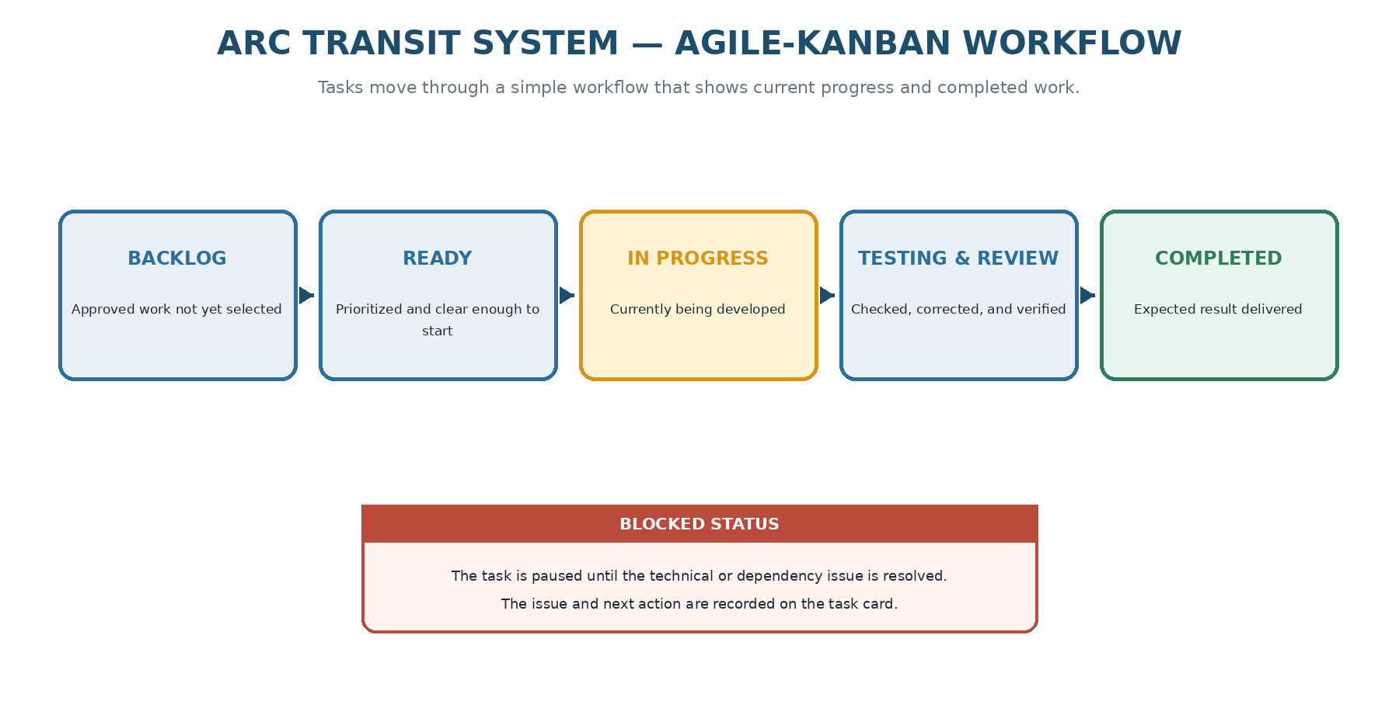
Figure 6.1. Agile-Kanban workflow used to track project progress.

Kanban Workflow
Each task is placed in the state that matches its current condition. A task moves forward when its expected output is ready for the next step. Blocked work remains visible until the issue is resolved.
State | Meaning
Planned | Approved project work that has not yet been selected for the current iteration.
Ready | Prioritized work with a clear objective, expected result, and known dependencies.
In Progress | The task is currently being designed, implemented, or documented.
Testing and Review | The output is being tested, checked, corrected, and compared with the task objective.
Completed | The expected result has been produced and the related code, tests, or documentation are updated.
Blocked | The task is temporarily paused because a technical or dependency issue prevents progress.

Development Timeline
The project is planned across twelve weeks. Two-week iterations provide regular progress checks, while individual tasks may move when learning, debugging, or integration requires more time. Weeks 1-4 established the documented design baseline. Week 5 begins implementation with the runnable application foundation.

Project Milestones
Milestone | Target | Expected accomplishment | Status
Research and constraint baseline | Week 2 | Philippine operating evidence and current production-system capability map are verified and source-linked. | Revised
Problem and feasibility baseline | Week 3 | Operational-state integrity problem, gap, proposed solution boundary, risks, trade-offs, and experiment plan are documented. | Planned
Architecture and data design | Week 4 | Operational state, provenance, freshness, reconciliation, route/version, database, service contracts, and security design are complete. | Planned
Application foundation | Week 5 | Current runtime baseline, PostgreSQL, Flyway, login, module structure, and test infrastructure run together. | Planned
Core operations | Week 8 | Fleet, Driver, Route, Dispatch, operational observations, incidents, maintenance, and state-history workflows operate together. | Planned
Reconciliation layer | Week 9 | Stale-state, contradiction, verification, and exception workflows operate with traceable history. | Planned
Evaluation release candidate | Week 11 | Controlled tests and benchmarks produce actual measured results and documented failure cases. | Planned
Final feasibility release | Week 12 | Working system, Project Plan, evidence register, experiments, limitations, deployment notes, and feasibility conclusions are complete. | Planned

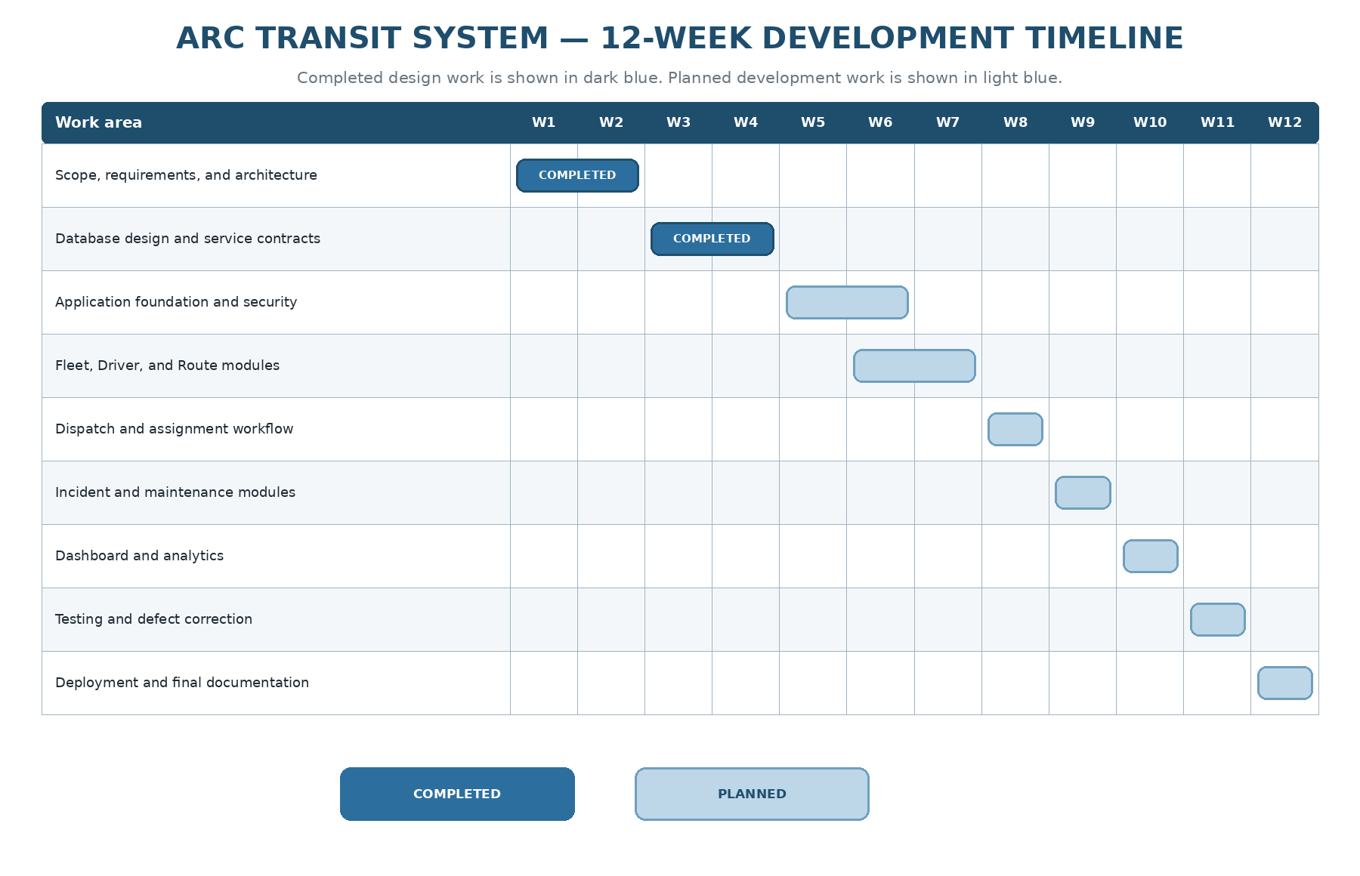
Figure 6.2. 12-week development timeline.

Detailed Weekly Work Plan
The weekly plan turns each milestone into specific work and an expected result. The status column is updated as the project progresses, making the document useful as both a plan and an accomplishment record.
Week | Main focus | Planned work | Expected result
Week 1 | Philippine operating constraints | Verify current Philippine transport evidence, define the target operating context, identify operational constraints, and separate verified facts from assumptions. | Evidence-backed constraint register and source map.
Week 2 | Market and production-system analysis | Compare fleet telematics, transit scheduling, CAD/AVL, disruption, government ITS, and manual-monitoring systems; document what is already solved and what assumptions they make. | Capability matrix and bounded gap analysis.
Week 3 | Problem definition and feasibility | Define the operational-state integrity problem, proposed intervention, feasibility criteria, risks, trade-offs, and measurement design. | Approved research hypothesis, solution boundary, and experiment plan.
Week 4 | Operational model and database revision | Finalize state machines, provenance/verification model, freshness rules, route versioning, assignment recovery, exception model, ERDs, constraints, and service contracts. | Revised technical baseline aligned with research.
Week 5 | Application foundation | Update Java/Spring/Vaadin baseline, create module structure, PostgreSQL/Flyway environment, authentication, deployment shell, and test infrastructure. | Runnable project with verified foundation.
Week 6 | Fleet, Driver, Route | Implement fleet dispatchability, operational observations, driver validation, route versions, stops, schedules, search, and forms. | Core master-data and observation workflows.
Week 7 | Dispatch and operational state | Implement dated assignments, lifecycle transitions, state events, conflict detection, freshness tracking, and replacement/recovery handling. | Working operational-state workflow.
Week 8 | Incident and Maintenance | Integrate incident response, maintenance effects, affected assignments, and recovery traceability. | Integrated disruption/recovery workflow.
Week 9 | Reconciliation and exceptions | Implement contradiction checks, stale-state rules, verification actions, exception queue, acknowledgement, and resolution. | Operational reconciliation layer.
Week 10 | Dashboard and experiments | Implement dashboards, filters, exception summaries, route presentation, controlled scenario generation, and measurement instrumentation. | Experiment-ready system and benchmark harness.
Week 11 | Testing and evaluation | Run unit, integration, security, migration, performance, stale-state, contradiction, recovery, and audit-completeness tests. Record actual results and failures. | Release candidate plus evidence package.
Week 12 | Feasibility assessment and release | Compare results with objectives, document limitations and trade-offs, decide which proposed enhancements remain feasible, and finalize deployment, README, diagrams, and source register. | Final Project Plan, working system, measured evaluation, and explicit feasibility conclusion.

Development - Backend Layout

Diagram Module Layout
The backend is organized by operational domain rather than generic CRUD screens. Each module owns its records and application services. Operational State / Reconciliation is implemented as a read/write coordination layer over append-only observations, assignment state, incidents, maintenance, and audit history.

Authentication and User Administration Module
Authentication owns staff accounts, roles, session authentication, authorization decisions, and administrator-only configuration. Drivers remain operational records unless a separate authenticated account is explicitly required.

Fleet Module
Fleet owns fleet identity, administrative availability, dispatchability, maintenance-blocked state, and append-only field observations. Fleet state must not collapse authorization, availability, assignment, and physical condition into one flag.

Driver Module
Driver owns identity, license validity, employment/availability state, and duty constraints used by dispatch validation. It does not attempt to solve recruitment or labour shortages.

Route Module
Route owns route definitions, route versions/effective periods, ordered stops, and recurring schedules. Historical service assignments reference the route context that was effective when the service was planned.

Dispatch and Assignment Module
Dispatch owns dated assignments, conflict checks, lifecycle transitions, cancellation, replacement, diversion, and completion. Audit/state events preserve the causal chain of operational changes.

Incident Module
Incident owns incident classification, severity, acknowledgement, actions, resolution, affected assignment/route/vehicle context, and links to maintenance or recovery actions when applicable.

Maintenance Module
Maintenance owns scheduled/corrective work and its effect on vehicle dispatchability. It records maintenance history but does not infer engine diagnostics or predictive failure without connected-vehicle data.

Analytics Module
Analytics reads operational facts and reconciliation outputs to present service capacity, stale-state queues, contradictory states, open incidents, maintenance effects, route-level disruption patterns, and audit/search summaries. Analytics does not own mutable operational truth.

Development - Frontend User Interface

Dashboard Overview
- Implement a Vaadin MainLayout with a top header, Arc Transit branding, global search, user/session controls, and clear separation between current operational condition and exception state. The dashboard must not present manually reported values as telemetry.
- DashboardView should show current usable service capacity, active assignments, stale observations, unresolved/critical exceptions, open incidents, maintenance-blocked units, and recent state changes. Replace “Live Fleet Monitor” wording with a label that does not imply automatic location telemetry.
- Use cross-view state/event communication where useful, but operational actions must route through application services rather than directly manipulating repository data from the UI.
- Use the existing enterprise Operations Command visual language while giving visual prominence to freshness, verification, and exception severity rather than decorative status colours alone.

Fleet Management UI
Provide fleet search, availability/dispatchability state, latest observation, freshness indicator, verification state, maintenance block, and controlled update actions.

Driver Management UI
Provide driver availability, license validity, assignment context, duty conflicts, and clear validation reasons when a driver cannot be assigned.

Route Management UI
Provide route definitions, route versions/effective periods, ordered stops, schedules, and historical context for assignments affected by route changes.

Dispatch Management UI
Provide a daily operational board with planned, assigned, dispatched, in-service, delayed, cancelled, curtailed, diverted, and completed states. Include replacement/recovery actions and conflict warnings.

Incident Management UI
Provide incident reporting with affected service context, source, observation time, severity, response actions, verification/reconciliation links, and complete resolution history.

Maintenance Management UI
Provide maintenance scheduling/completion, current dispatchability effect, maintenance history, and links from maintenance-triggering incidents.

Analytics UI
Provide read-only operational summaries, exception queues, freshness metrics, route-level incident/dispatch summaries, and audit-query functions appropriate to the user role.

Fixed Route Mapping UI
Provide static route geometry and ordered stop markers. No live GPS display is implied. A later integration may add telemetry as a distinct source type rather than replacing manual history.

Testing and Debugging

Debugging
Use automated browser interaction testing and controlled workflow scripts to verify search, dispatch, observation submission, verification, exception acknowledgement, incident recovery, and route/version presentation. UI automation is evidence of interface behaviour only; it is not evidence of real-world transport effectiveness.

Unit Testing
Unit-test domain invariants, state transitions, freshness calculations, verification rules, exception classification, and command validation. Include negative cases for invalid transitions and missing or contradictory operational evidence.

Integration Testing
Integration-test PostgreSQL persistence, Flyway migrations, optimistic locking, foreign-key integrity, assignment overlap detection, append-only observation/state history, route-version handling, and reconciliation queries using PostgreSQL Testcontainers.

Application Service Testing
Test complete use cases: create and dispatch an assignment, submit a delayed observation, allow it to become stale, verify it, create a contradictory assignment condition, cancel/replace a trip, and reconstruct the causal history.

Bug Tracking
Track defects by severity and failure mode. Separate software defects from evidence gaps and feasibility failures so the project does not treat an unmeasurable real-world assumption as merely a coding bug.

Test Results
Test results must record actual outcomes against planned targets. Research claims, prototype measurements, and feasibility conclusions must be separated from unsupported city-scale outcome claims.

Deployment

Deployment Architecture
Deployment remains a single application container plus PostgreSQL for the baseline. The deployment demonstrates reproducibility and safe separation of the database from the public network; it does not demonstrate production authority readiness.

Docker Configuration
Docker Compose defines the application and PostgreSQL services, persistent database storage, health checks where appropriate, environment-driven configuration, and a non-public database port. Production secrets are supplied through the deployment environment rather than committed to source control.

Oracle Cloud Configuration
Oracle Cloud or another VM provider may host a demonstration environment. Provider choice is an implementation convenience, not part of the transport solution claim. Cloud deployment does not establish production availability, redundancy, or public-sector compliance.

Environment Variables
Environment variables hold database credentials, application secrets, external service keys if later introduced, logging configuration, and deployment-specific URLs. No research data or personal credentials are embedded in the image.

Deployment Procedure
Deployment procedure should be reproducible from the documented repository: provision VM/runtime, configure environment variables, start PostgreSQL/application services, apply Flyway migrations, create initial administrator access, run smoke tests, and verify health/log output.

Rollback Procedure
Rollback should restore the previous application image and configuration while preserving operational history. Database migrations are forward-only unless a tested rollback path exists; destructive schema rollback is not assumed to be safe.

Documentation

GitHub Repository Structure
Repository structure should separate application modules, infrastructure/deployment files, database migrations, automated tests, research/evidence documents, diagrams, and experiment results. Research sources used to justify requirements must be identifiable from the repository.

README
README should explain the operational problem, research basis, system boundary, architecture, setup, benchmark procedure, controlled experiments, measured results, known limitations, and explicit statements of what the system does not prove.

Architecture Artifacts
Architecture artifacts should include the system context, operational state machine, reconciliation flow, module dependency view, ERD, route/version model, assignment lifecycle, incident/recovery flow, and evidence/exception model.

Screenshots
Screenshots should document the dashboard, exception queue, fleet state, dispatch board, route versioning, observation verification, incident/recovery workflow, and audit history. Screenshots must represent actual implemented behaviour.

Lessons Learned
Lessons learned should distinguish technical lessons, operational assumptions, evidence limitations, failed hypotheses, data-quality problems, and trade-offs discovered during implementation and controlled testing.

Future Roadmap
Future roadmap should prioritize evidence-backed extensions: optional telemetry ingestion, QR-assisted reporting experiment, offline synchronization only if field research justifies it, external identity integration if needed, passenger-information integration only with a validated operational data source, and deeper optimization only if the project obtains a real scheduling problem and suitable data. None of these extensions should be presented as inherently beneficial without validation.
Source register used for research-derived requirements and current-technology verification:
[S1] Philippine Information Agency, “DOTr chief wants more PUVs on Commonwealth Avenue” (September 25, 2025): https://pia.gov.ph/news/dotr-chief-wants-more-puvs-on-commonwealth-avenue/
[S2] Philippine Information Agency, “Service Contracting Program? Here’s what you need to know” (April 15, 2026): https://pia.gov.ph/news/service-contracting-program-heres-what-you-need-to-know/
[S3] Philippine Information Agency, “Marcos Jr. eases GPS rule to widen PUV subsidy program reach” (April 21, 2026): https://pia.gov.ph/news/marcos-jr-eases-gps-rule-to-widen-puv-subsidy-program-reach/
[S4] Philippine News Agency, “LTFRB ‘rationalizes’ 12 PUV routes in NCR, Rizal, Surigao Sur” (January 29, 2026): https://www.pna.gov.ph/articles/1268016
[S5] Land Transportation Office, “Mobile Motor Vehicle Inspection Facility” (May 13, 2025): https://lto.gov.ph/news/mobile-motor-vehicle-inspection-facility/
[S6] INIT, “Ghost Buses: When Transit Data Haunts Your Riders” (2025): https://www.initse.com/enus/news-resources/knowledge-database/2025/ghost-buses-when-transit-data-haunts-your-riders-1/
[S7] Samsara, “Telematics”: https://www.samsara.com/products/telematics
[S8] Geotab, APAC fleet-management platform: https://www.geotab.com/apac/
[S9] Optibus, public transportation operations platform: https://optibus.com/product/ and https://optibus.com/product/operations/
[S10] GIRO, HASTUS for Schedulers: https://www.giro.ca/en-us/our-solutions/hastus-software/hastus-for-schedulers/
[S11] Clever Devices, CleverCAD: https://www.cleverdevices.com/products/clevercad/
[S12] Seoul TOPIS, BMS/BIS: https://topis.seoul.go.kr/openEngBms.do
[S13] Spring Boot official project/system requirements, current stable 4.1.0: https://spring.io/projects/spring-boot/ and https://docs.spring.io/spring-boot/system-requirements.html
[S14] Vaadin, current upgrade guidance for Vaadin 25: https://vaadin.com/docs/latest/upgrading
[S15] Spring Modulith official documentation/release index, stable 2.1.x: https://docs.spring.io/spring-modulith/docs/
Source-use rule: these sources support the external operating-context and technology statements in the plan. Project design choices, proposed enhancements, benchmark targets, and feasibility conclusions remain engineering proposals or measured results and are not presented as externally established facts.

Developed By
Chuckz Española

